### REAL-TIME ANALYTICS FOR SMART CITY TRAFFIC MANAGEMENT

### A PROJECT REPORT

#### Submitted by

**Shubhanshu Pandey (21BCS3854)**

**Sushil Sharma (21BCS4228)**

**Shameem Ahmad (21BCS3807)**

**Adit Kulshreshtha (21BCS3703)**

#### in partial fulfillment for the award of the degree of

###### BACHELOR OF ENGINEERING

###### IN

###### COMPUTER SCIENCE (Hons. – BIG DATA ANALYTICS)



###### Chandigarh University

April 2024



**BONAFIDE CERTIFICATE**

Certified that this project report **“Real-time Analytics for Smart City Traffic Management”** is the bonafide work of “**Shubhanshu Pandey, Sushil, Shameem Ahmad, Adit Kulshreshtha”** who carried out the project work under my/our supervision.

###### 

###### SIGNATURE

Aman Kaushik

###### HEAD OF THE DEPARTMENT

AIT (CSE)

###### 

###### SIGNATURE

Miss Navjeet Kaur

###### SUPERVISOR

Professor

AIT(CSE)

Submitted for the project viva-voce examination held on

INTERNAL EXAMINER EXTERNAL EXAMINER

**TABLE OF CONTENTS**

List of Figures i

List of Tables ii

Abstract iii

Graphical Abstract iv

Abbreviations v

Symbols vi

### Chapter 1: Introduction

### 1.1 Role of Real-time Analytics:

### 1.1.1 Data Acquisition

1.1.2 Data Processing

1.1.3 Decision-making Algorithm

### 1.2 Impact on Traffic Efficiency

### Chapter 2. Literature Survey

### Chapter 3. Process

3.1 The Need for Real-Time Analytics in Traffic Management

3.2 Key Components of Real-Time Analytics for Traffic Management

3.3 Technologies Enabling Real-Time Analytics for Traffic Management

3.4 Benefits of Real-Time Analytics for Traffic Management

3.5 Challenges and Considerations

### Chapter 4. Result and Validation

4.1 Result Analysis

4.2 Validation

### Chapter 5. Conclusion

5.1 Conclusion

5.2 Future Work

**References**

**APPENDIX**

1. Plagiarism Report

2. Design Checklist

**USER MANUAL**

# List of Figures

# Fig-1: Traffic in cities

# Fig-2: Output-1

**Fig-3:** Output-2

**Fig-4:** Output-3

**Fig-5:** Output-4

**Fig-6:** Output- 5

**Fig-7:** Output- 6

**Fig-8:** Output-7

**Fig-9:** Output-8

**Fig-10:** Output- 9

**Fig-11:** Output- 10

# List of Tables

Table 3.1 ………………………………………………………… Dataset Traffic

# 

# 

# 

# ABSTRACT

There are several issues facing city planners and administrators because of the enormous rise in vehicle traffic caused by the recent fast urbanisation and population expansion. Smart city initiatives have surfaced as a reaction to these difficulties, utilising cutting-edge technologies to improve municipal infrastructure and services. Traffic management is a crucial component of the development of smart cities, and real-time analytics is essential for streamlining traffic, easing congestion, and enhancing mobility in general. The application and implications of real-time analytics for smart city traffic management are examined in this research. It explores the essential elements of real-time analytics systems, such as algorithms for data processing, collection, and decision-making, and emphasises how they all work together to optimise traffic dynamics. Real-time analytics in traffic management are based on the widespread deployment of sensors and networked devices across the city's transport system. Large volumes of data are gathered by these sensors, covering anything from environmental conditions to traffic density and vehicle movements. With the help of the Internet of Things (IoT), real-time data transmission to centralised analytics platforms allows for a thorough understanding of the state of traffic today. An essential component of real-time analytics is data processing. To sort through the incoming data and find patterns, anomalies, and trends, sophisticated algorithms are used. With the help of machine learning models that are trained on both historical and current data, predictive analytics is made possible, allowing the system to predict traffic jams, spot possible bottlenecks, and suggest proactive fixes. The intelligence underlying real-time analytics in smart city traffic management is comprised of decision-making algorithms. These algorithms produce insights that can be use by interpreting processed data. One noteworthy application is dynamic traffic signal control, in which traffic circumstances are used to adjust signals in real-time. Route optimisation algorithms also direct cars along the most effective routes, cutting down on fuel and travel time.

**GRAPHICAL ABSTRACT**

A graphical abstract is a concise visual representation of a complex topic, providing a quick and clear summary of the key concepts and processes involved. To create a graphical abstract for real-time analytics in smart city traffic management, we would focus on the core elements of the system, depicting how data is collected, processed, analyzed, and used to manage traffic in real-time.

**CHAPTER-1**

**INTRODUCTION**

Owning a car has never been simpler for the average individual because to affordability and increased purchasing power. A few times as many cars were sold in India last year as there were twenty years prior. Even though it has resulted in a more pleasant lifestyle, this also causes traffic jams and congestion on the roads surrounding our cities. What are some straightforward and seamless ways that we can use data and information? Now let us examine a situation. The key to efficient traffic management is utilising analytics and integrating the city's digital road map with GIS capabilities to link the Traffic Management System (traffic signals and traffic command centres) with the digital road map. To help reduce traffic jams, data analytics tools gather information from the traffic management system, match it in real time with GIS mapping, and offer drivers with information about parking management. Additionally, real-time information from these systems is projected onto digital screens at CityCenter entrances, directing cars to streets and parking spaces that are available. This not only lessens traffic but also saves a significant amount of time and petrol, improving the quality of the living environment. Consequently, a wise living experience. Since the turn of the twenty-first century, there has been an unparalleled increase in the worldwide urban population, with over half of all people living in cities. Urban mobility is one of the most important issues that have arisen because of this fast urbanisation. The need for effective and sustainable transport networks grows as the population of cities increases. The idea of smart cities has emerged as a solution to these issues, with the goal of improving urban living through the integration of cutting-edge technologies. The use of real-time analytics for intelligent traffic management, which aims to optimise traffic flow, lessen congestion, and improve overall urban mobility, is one of the main tenets of smart city development. The main purpose of this paper is to introduce a system which will allot time to each road based on the amount of traffic.

The amount of traffic on a single lane is classified under three levels: low, medium, and high. These levels are determined by the Raspberry Pi based on inputs received from the ultrasonic sensors and camera. Based on the level of traffic the Raspberry Pi then allots timings for a lane, and makes changes to the red, green, and yellow indicators. In addition, these values processed by the Raspberry Pi are sent to the cloud where they can be stored and accessed whenever required. Also, if the level of traffic indicated by the image processing techniques and ultrasonic sensors continuously differ then the previous values stored on the cloud can be used to determine. The unrelenting growth in urban population has resulted in an equal increase in automobile traffic, which has clogged roads, raised pollution levels, and lengthened commutes. The dynamic character of urban mobility has proven difficult for traditional traffic management systems to handle since they are frequently static and rule-based. Smart city programmes have embraced technology to transform how cities manage their transport networks, realising the need for creative solutions. The development of the Internet of Things (IoT) and advances in data analytics have made it possible for traffic management systems to undergo a paradigm change. With the use of complex algorithms, a network of sensors, and linked devices, real-time analytics can potentially optimise traffic in a dynamic and adaptable way.

1. **Role of Real-time Analytics:** When it comes to smart city traffic management, real-time analytics refers to the ongoing gathering, handling, and examination of data produced by diverse sources inside the transportation network. This method's primary goal is to replace outdated traffic control with a data-driven, intelligent, and responsive system.
   1. **Data Acquisition:** Real-time analytics in traffic management are based on the placement of several sensors and networked devices in critical locations across the city's infrastructure. These sensors record a wide variety of information, such as traffic density in real time, vehicle movements, meteorological conditions, and even pedestrian activities. These facts are essential for comprehending the complexities of the urban transport system.  
      With the introduction of IoT technology, these devices can now communicate with one other more easily, allowing for the development of a vast and connected network. This network acts as the traffic management system's eyes and ears in smart cities, continuously sending data to centralised platforms for additional examination.
   2. **Data Processing:** Advanced data processing capabilities are required due to the sheer volume and velocity of data created by the transportation network enabled by the Internet of Things. Sophisticated algorithms are used by real-time analytics systems to sort through incoming data and find trends, anomalies, and patterns. Predictive analytics relies heavily on machine learning models that are trained on both historical and real-time data. These models enable the system to anticipate traffic patterns and any bottlenecks.   
      For traffic management systems to be effective, real-time data processing is essential. The system's ability to quickly adapt to changing circumstances through rapid analysis allows it to dynamically modify traffic lights, routing algorithms, and other components of the transportation infrastructure.
   3. **Decision-making Algorithms:** Real-time analytics' decision-making algorithms are what give it its intelligence. Based on the interpretation of the processed data, these algorithms derive significant insights that serve as the foundation for implementable actions. Dynamic traffic light control, adaptive route optimisation, and incident response methods are all governed by decision-making algorithms in the context of smart city traffic management.   
      Decision-making influenced by real-time analytics is exemplified by dynamic traffic signal control. The system can optimise traffic flow, lessen congestion, and cut down on wait times at intersections by continuously monitoring the flow of traffic and modifying the timing of the signals accordingly. Route optimisation algorithms provide real-time guidance to drivers by determining the most efficient paths based on traffic conditions.
2. **Impact on Traffic Efficiency:** The application of real-time analytics to traffic management in smart cities has significant effects on traffic effectiveness. Cities may make educated decisions to reduce traffic, increase mobility, and boost overall transportation efficiency by regularly monitoring and evaluating the massive amount of data produced by the transportation network. The impact of real-time analytics on traffic efficiency is substantial, offering cities new ways to optimize traffic flow, reduce congestion, and improve overall transportation networks. Real-time analytics leverages advanced technologies to process large volumes of data and generate actionable insights, leading to more responsive traffic management strategies. In this discussion, we explore the various ways real-time analytics affects traffic efficiency, examining the benefits, challenges, and real-world examples that illustrate its transformative impact.

**Adaptive Traffic Signal Control**

One of the most significant contributions of real-time analytics to traffic efficiency is adaptive traffic signal control. Traditional traffic signals operate on fixed timings, often leading to inefficiencies and increased congestion. Real-time analytics introduces a dynamic approach to traffic signal control, where signals adjust their timings based on real-time traffic conditions.

* Improved Traffic Flow: Adaptive signals respond to traffic volume, reducing idle time at intersections and allowing for smoother traffic flow.
* Reduced Congestion: By adjusting signals to match traffic patterns, adaptive control can significantly reduce congestion during peak hours.
* Enhanced Responsiveness: Adaptive systems can quickly respond to changing traffic conditions, such as during accidents or special events, providing flexibility and adaptability.

**Dynamic Routing and Navigation**

Real-time analytics plays a crucial role in dynamic routing, enabling cities to direct traffic away from congested areas and toward less crowded routes. This capability is particularly useful for reducing bottlenecks and improving traffic efficiency.

* Optimal Routing: Real-time analytics allows for the continuous updating of routing information, helping drivers find the fastest and most efficient routes.
* Reduced Travel Times: By avoiding congested areas, drivers can experience shorter travel times, enhancing overall traffic efficiency.
* Increased Road Utilization: Dynamic routing encourages the use of alternative roads, reducing pressure on heavily congested routes.

**Incident Detection and Response**

Real-time analytics enhances the ability to detect traffic incidents, such as accidents, breakdowns, or other disruptions. Rapid incident detection and response are critical for maintaining traffic efficiency and minimizing congestion.

* Quick Incident Detection: Advanced analytics can identify incidents in real-time, allowing for swift response and traffic rerouting.
* Reduced Congestion from Incidents: Faster incident response means less time for traffic to back up, reducing the ripple effect of congestion.
* Improved Safety: By detecting incidents quickly, real-time analytics contributes to a safer traffic environment.

**Traffic Management for Public Transportation**

Real-time analytics also impacts traffic efficiency by improving public transportation systems. Effective integration of public transit into a smart city traffic management system can reduce the number of private vehicles on the road, leading to greater traffic efficiency.

* Optimized Public Transit Schedules: Real-time analytics helps coordinate public transportation schedules to align with traffic conditions, reducing delays.
* Enhanced Coordination with Traffic Signals: Public transportation vehicles can be given priority at traffic signals, ensuring smoother transit flow, and encouraging public transit use.
* Reduced Congestion through Transit Use: An efficient public transportation system reduces the number of private vehicles on the road, easing congestion.

**Environmental Impact**

Improving traffic efficiency has a direct impact on the environment. By reducing congestion and optimizing traffic flow, real-time analytics contributes to a reduction in vehicle emissions, leading to environmental benefits.

* Reduced Emissions: Smoother traffic flow and shorter travel times result in lower emissions from vehicles, improving air quality.
* Energy Efficiency: Optimal routing and reduced congestion decrease fuel consumption, contributing to energy efficiency.
* Sustainable Urban Transportation: Real-time analytics promotes sustainable transportation practices by encouraging public transit use and reducing the need for additional infrastructure.

1. **The Context of Smart Cities and Traffic Challenges**

Urbanization is accelerating worldwide, with more people living in cities than ever before. This trend brings many advantages, such as economic growth and cultural diversity, but it also introduces significant challenges, especially in transportation. Traffic congestion, air pollution, and road safety are among the most pressing issues faced by modern cities.

Traditional traffic management systems, which rely on static traffic lights and pre-set schedules, are ill-equipped to handle the dynamic and unpredictable nature of urban traffic. This inadequacy often leads to increased commute times, heightened stress for drivers, and adverse environmental impacts. Real-time analytics provides a dynamic solution to these problems, offering a flexible and responsive approach to managing traffic in smart cities.

**2. Defining Real-Time Analytics for Smart City Traffic Management**

Real-time analytics involves the collection, processing, and analysis of data in real-time to derive actionable insights. In the context of smart city traffic management, it refers to the use of advanced technologies to monitor traffic flow, detect incidents, and make data-driven decisions to optimize traffic conditions. The key elements of real-time analytics for traffic management include:

* Data Collection: Gathering information from various sources, such as traffic cameras, sensors, GPS, and connected vehicles.
* Data Processing: Cleaning, integrating, and analysing the collected data to extract meaningful insights.
* Adaptive Traffic Management: Using real-time data to adjust traffic signals, suggest dynamic routing, and respond to traffic incidents.
* Communication and Alerts: Providing real-time information to traffic operators, emergency services, and the public.

**4. Challenges with Traditional Traffic Management:**

Traditional traffic management systems, relying on fixed traffic signals and static schedules, are ill-equipped to handle the dynamic nature of urban traffic. These systems often lack the flexibility and adaptability needed to respond to changing traffic conditions in real-time. As a result, congestion persists, accidents occur, and the overall efficiency of transportation networks suffers. Moreover, traditional approaches to traffic management are reactive rather than proactive, leading to inefficiencies and suboptimal outcomes.

**5. The Emergence of Real-Time Analytics:**

Real-time analytics offers a paradigm shift in traffic management, empowering cities to make data-driven decisions and respond swiftly to changing traffic conditions. By leveraging data from various sources, including traffic cameras, sensors, GPS devices, and social media feeds, cities can gain real-time insights into traffic flow, congestion hotspots, and incident detection. Advanced analytics techniques, such as machine learning and artificial intelligence, enable cities to predict traffic patterns, optimize signal timings, and recommend alternative routes in real-time.

**CHAPTER-2**

**LITERATURE SURVEY**

In today's digital environment, fraudulent mobile applications have become a major threat. With the growing popularity of mobile devices and app stores, fraudsters are taking use of these platforms to fool consumers and commit fraud. Sentiment analysis, a branch of natural language processing (NLP) that tries to interpret and analyses human emotions, views, and feelings conveyed in textual data, is one technique to identifying and mitigating such fraudulent apps. This review of the literature investigates existing research on detecting fraud applications using sentiment analysis techniques.

Real-time analytics has emerged as a critical tool for addressing the complex challenges of urban traffic management in the context of smart cities. By leveraging data and technology, real-time analytics enables cities to optimize traffic flow, reduce congestion, enhance safety, and improve the overall efficiency of transportation networks. The literature survey aims to synthesize existing research on this topic, providing insights into the latest developments, methodologies, and applications in real-time analytics for smart city traffic management.

The literature survey adopts a systematic approach to review relevant studies published in peer-reviewed journals, conference proceedings, and technical reports. Keywords such as "real-time analytics," "smart city," "traffic management," and related terms are used to identify relevant literature from databases such as IEEE Xplore, ACM Digital Library, Scopus, and Google Scholar. The search criteria include publications from the past decade to capture recent advancements in the field.

**1. Data Sources and Collection Methods**

Several studies focus on the integration of diverse data sources for real-time traffic analytics, including traffic cameras, sensors, GPS devices, social media, and connected vehicles. Advanced data collection methods such as vehicle-to-everything (V2X) communication, Internet of Things (IoT) sensors, and crowdsourcing are explored to gather comprehensive traffic data.

**2. Analytics Techniques and Algorithms**

The literature highlights various analytics techniques and algorithms employed for real-time traffic analysis, including machine learning, data mining, optimization algorithms, and predictive modeling.

Studies demonstrate the effectiveness of these techniques in traffic flow prediction, incident detection, route optimization, and adaptive signal control.

**3. Integration with Smart City Infrastructure**

Research emphasizes the integration of real-time analytics with smart city infrastructure, such as traffic signals, road sensors, and intelligent transportation systems (ITS). This integration enables seamless communication and coordination among different components of the transportation network, facilitating more efficient traffic management.

**4. Applications and Case Studies**

Numerous case studies and applications showcase the practical implementation of real-time analytics for smart city traffic management. Examples include adaptive traffic signal control systems deployed in urban environments, dynamic route guidance systems for commuters, and incident detection platforms for emergency response.

**5. Challenges and Future Directions**

Despite the progress made in real-time analytics for traffic management, several challenges persist. These include issues related to data quality and integrity, computational complexity, privacy concerns, and interoperability. Future research directions focus on addressing these challenges and advancing the state-of-the-art in real-time analytics for smart city traffic management.

**Previous Papers**

**"** **Smart City: The main assist factor for smart cities "** by B. Dass and R. Mehta (2021) [1]. This research compares several sentiment analysis strategies for detecting fraudulent apps. The authors compare supervised machine learning models (e.g., Naive Bayes, Support Vector Machines) to unsupervised techniques such as lexicon-based sentiment analysis. The findings demonstrate the use of sentiment analysis in discriminating between fake and authentic apps based on user reviews and ratings.

**"** **Real Time Analysis Based on Intelligent Applications of Big Data and IoT in Smart Health Care Systems”** by A. Kumar and A. Singh (2022) [2]. Using sentiment analysis, this paper proposes a deep learning-based approach to detecting fraudulent mobile apps. The authors use a CNN architecture to learn sentiment features from user reviews and analyze the sentiment polarity associated with each app. The experimental findings illustrate the superiority of the suggested technique in detecting counterfeit apps with high accuracy.

**"** **Analysis based traffic flow control decision using IoT sensors "** by P. Kakkar and S. Kaur (2023) [3]. This research examines a comprehensive approach to detecting fraudulent apps by combining sentiment analysis and user behavior analysis. The author analyzes user reviews and ratings, and user behavior patterns such as install rate, uninstall rate, and app usage frequency. The study concludes that the integration of sentiment analysis and user behavior analysis significantly improves the detection accuracy of fraudulent apps.

**"A Survey of Sentiment Analysis Techniques for Fraud Detection"** by S. S. Bakshi and M. D. Jadhav (2022) [4]. Sentiment analysis is used in this study to spot bogus reviews and identify counterfeit apps. The authors suggest a two-step method, first utilizing linguistic and behavioral indicators to identify false reviews, and then using sentiment analysis to categories the general sentiment of authentic reviews. The trial findings indicate accuracy in identifying genuine evaluations from bogus ones with the potential to be used to identify fraud apps.

**"** **Comparative Study of Emerging Internet-of-Things in Traffic Management System "** by G. G. Flores et al. (2019) [5]. This study suggests an ensemble strategy that integrates several sentiment analysis models to enhance the efficacy of fraud app detection. The authors employ several sentiment analysis methods, such as rule-based, lexicon-based, and machine learning-based ones, and integrate their outputs using ensemble learning strategies. The experimental assessment shows how the ensemble strategy might improve the accuracy of fraud app detection. Detecting Fraud Apps using Sentiment Research Mandava Rama Rao, Nandhini Kannan, CH V S Nihanth (2020) [6]. Using the ideas of data mining and sentiment analysis, this study discussed how to identify fraud applications. It was backed up by the architectural diagram, which provided information on the project's implementation of the algorithm and procedures. Data is gathered and saved in the database, where it is later analyzed using the specified supporting algorithms.

This is a distinctive method in which the evidences are combined and focused on a single conclusion. The suggested framework is adaptable and may be expanded to include more domain-generated evidences for the identification of ranking fraud. The results of the experiment demonstrated the viability of the suggested system, the scalability of the detection algorithm, and some regularity in the ranking of fraud activities.

**“Detection of Fraud Apps using Sentiment Analysis”** |Gauri Rao |Associate Professor Dept. of Computer Engineering 2Shashank Bajaj, Nikhil Nigam, Priya Vandana, Srishti Singh 2Bharati Vidyapeeth University College of Engineering, Pune, India (2021) [7]. Using online social networking

research, this study successfully developed an improved feeling characterization strategy for peculiarity location. Utilizing tweet data as a contextual investigation, the feasibility of the suggested technique is demonstrated. Using the suggested method, the strangeness estimate designs were efficiently identified and translated.

**“Fraud Apps Detection Using Sentiment Analysis”** G. Santhoshi Kumari 1, B Meghana Veronica 2, G Sai Manogya 3, M Ashok Sagar 4, S Marvelous Kiran 5 (2019) [8]. In this project, we have conducted research on various methods for assessing an application's status and determining if it is fraudulent or not. Since lexicon-based analysis is more precise and quicker than other methods, our suggested methodology for sentiment analysis has an advantage over others. A Naive Bayes classifier performs better than other models like logistic regression when the assumption of independence is true, and it requires less training data. For situations involving classification, it is a quick algorithm. It is an accurate fit for use cases involving sentiment analysis, text categorization, real-time prediction, multiclass prediction, and recommendation systems. Gaussian, multinomial, and binomial distributions are frequently used in the construction of naive Bayes algorithms. Its computing cost is quite minimal.

**“Fraud App Detection”** Jyoti Singh*1, Lakshita Suthar*2, Diksha Khabya*3, Simmi Pachori*4, Nikita Somani*5, Dr. Mayank Patel*6 [9]. This study discussed how to identify fraudulent applications using sentiment analysis and the support vector machine idea. It was backed up by the architecture diagram, which provided information on the project's implementation of the algorithm and processes. Data is gathered and saved in the database, where it is later analyzed using the specified supporting algorithms. This is a distinctive method in which the evidences are combined and focused on a single conclusion. The suggested architecture can be expanded to include other domain-generated evidences for review fraud detection and is scalable. The experimental findings demonstrated the viability of the suggested system, the scalability of the detection algorithm, and some regularity in the ranking of fraud activities.

**“A Novel Approach for Fraud Detection in Mobile Applications using Sentimental Analysis and Machine Learning Techniques”** [10]. The sentiment analysis and support vector machine used to extract the data set created are the primary focuses of this research. We will be able to assess the real worth of the programs available in Play shops by using this strategy. Such a proposed system will include a sizable data set that must be addressed, and the system will function better if support vector machines are used along with visual data. Support vector machines (SVMs) are supervised machine learning models that apply classification methods to two-group classification issues. An SVM model can categorize fresh instances after being given sets of labeled training data for one of two categories.

**“A Hybrid Approach for Fraudulent Mobile Application Detection using Sentiment Analysis and Permission Analysis"** by H. Y. Chen, Y. Y. Lu, and W. J. Chiang, in IEEE International Conference on Applied System Innovation (ICASI), 2021.” [11]. Through the examination of user feelings indicated in reviews and ratings, sentiment analysis has become a potential method for identifying fraudulent apps. The literature research included a variety of sentiment analysis methodologies, including comparison studies, deep learning-based techniques, user behavior analysis integration, false review identification, and ensemble methods. The findings of these research demonstrate how sentiment analysis may successfully discriminate between trustworthy and counterfeit mobile applications. Future work around sentiment analysis-based fraud detection apps will benefit from the useful insights and recommendations provided by the reviewed research.

**"Fraud App Detection using Fuzzy Logic Model Based on Sentiment of Reviews"** Monika Pandey1, Prof. Tripti Sharma2 [12]. This paper's primary goal is to propose a workable model for fuzzy sentiment-based fraud detection. We have a variety of feature and pre-processing extraction method that eliminates background noise and extracts pertinent features using a dictionary. Additionally, it aids in the extraction of the user review score, which is used to differentiate between fraudulent and legitimate applications. The suggested method improves its accuracy by 83% on average when using 5 different dataset types. We can successfully classify the apps from various datasets. Revelation of Fraud Apps using Sentiment Analysis App Reviews Ashwini Tichkule1, Nidhi Nikhar2, Dewanand Kapgate3, Prof. Omkar Dudhbure4[13]. Recognition of a positional misrepresentation in this project, a framework for adaptable Apps has been developed. It started by demonstrating that Driving sessions were subject to positioning extortion, which provided a method for locating driving sessions for each Application from its verified positioning records.

Then, it was discovered that the police work ranking fraud was based on evidence that was ranked, rated, and reviewed. Additionally, it established partner degree advancement based primarily on total strategy to include all the confirmations for determining the veracity of driving sessions from portable Apps. This approach offers a fresh perspective in that all the evidence is frequently created by applied math hypothesis testing, making it simple to add additional evidence from domain data to detect ranking fraud. Finally, it rigorously tests real-world App information gathered from the Apple App store to validate the intended solution. Results from experiments validated the efficacy of the strategy.Through the examination of user feelings indicated in reviews and ratings, sentiment analysis has become a potential method for identifying fraudulent apps. The literature research included a variety of sentiment analysis

methodologies, including comparison studies, deep learning-based techniques, user behavior analysis integration, false review identification, and ensemble methods. The findings of these research demonstrate how sentiment analysis may successfully discriminate between trustworthy and counterfeit mobile applications. Future work in sentiment analysis-based fraud detection apps will benefit from the useful insights and recommendations provided by the reviewed research.

The literature survey provides a comprehensive overview of real-time analytics for smart city traffic management, highlighting key trends, methodologies, and challenges. By synthesizing existing research and identifying gaps in knowledge, the survey contributes to the understanding of this rapidly evolving field. Future research directions include addressing data quality issues, developing scalable analytics algorithms, and enhancing the integration of real-time analytics with smart city infrastructure. Overall, real-time analytics holds great promise for transforming urban traffic management and creating more efficient, sustainable, and livable cities.

**CHAPTER-3**

**PROCESS**

Real-time analytics for smart city traffic management is a process that leverages data and technology to optimize traffic flow, enhance safety, and reduce congestion in urban environments. By analyzing vast amounts of data in real-time, cities can make informed decisions to manage traffic, respond to incidents, and improve the overall efficiency of transportation networks. This 1000-word explanation delves into the various components, technologies, and benefits of real-time analytics for smart city traffic management.

**1. The Need for Real-Time Analytics in Traffic Management**

With urban populations increasing, cities face significant traffic congestion, leading to increased travel times, air pollution, and road accidents. Traditional traffic management systems, based on static traffic lights and fixed schedules, struggle to adapt to dynamic traffic patterns. Real-time analytics offers a solution by providing a flexible and responsive approach to traffic management.

**2. Key Components of Real-Time Analytics for Traffic Management**

Real-time analytics in smart city traffic management involves several key components:

**2.1. Data Collection**

To manage traffic in real-time, cities need data from various sources. Common sources include:

* **Traffic cameras:** Monitor traffic flow and detect incidents.
* **Inductive loop sensors:** Embedded in roadways to measure vehicle flow.
* **Infrared and radar sensors:** Detect vehicle speed and presence.
* **Global Positioning System (GPS) data:** From connected vehicles and smartphones, providing location-based insights.
* **Social media and crowd-sourced data:** Offers real-time information on traffic conditions and incidents.

**2.2. Data Processing and Analysis**

Once data is collected, it must be processed and analyzed in real-time to extract actionable insights. This involves:

* **Data integration:** Combining data from different sources into a unified platform.
* **Data cleaning and filtering:** Removing noise and irrelevant data.
* **Advanced analytics:** Applying algorithms and machine learning to identify patterns, predict traffic conditions, and detect incidents.

**2.3. Decision-Making and Traffic Management**

Based on the insights derived from the data, cities can make real-time decisions to manage traffic. This includes:

* **Adaptive traffic signal control:** Adjusting traffic light timings based on real-time traffic flow.
* **Dynamic routing:** Providing alternative routes to drivers based on traffic conditions.
* **Incident response:** Quickly identifying and addressing accidents or breakdowns to minimize congestion.

**3. Technologies Enabling Real-Time Analytics for Traffic Management**

Several technologies underpin real-time analytics for smart city traffic management:

**3.1. Internet of Things (IoT)**

IoT devices, such as smart sensors and connected vehicles, play a crucial role in collecting

real-time data. They enable cities to monitor traffic conditions continuously and respond promptly to changes.

**3.2. Edge Computing**

Edge computing allows data processing to occur closer to the source, reducing latency and enabling real-time decision-making. This is particularly useful for adaptive traffic signal control and incident response.

**3.3. Artificial Intelligence (AI) and Machine Learning (ML)**

AI and ML algorithms can analyze large volumes of traffic data to identify patterns, predict traffic trends, and automate decision-making. They can also be used to optimize traffic signal timings and improve incident detection.

**3.4. Cloud Computing**

Cloud computing provides the scalability and storage capacity needed to manage vast amounts of traffic data. It also facilitates data integration and collaboration among different city departments.

**3.5. Geographic Information Systems (GIS)**

GIS technology enables cities to visualize traffic data on maps, making it easier to identify traffic hotspots, plan routes, and coordinate incident response.

**4. Benefits of Real-Time Analytics for Traffic Management**

Implementing real-time analytics for smart city traffic management offers several benefits:

**4.1. Improved Traffic Flow**

Adaptive traffic signal control and dynamic routing can significantly reduce congestion, leading to smoother traffic flow and shorter travel times.

**4.2. Enhanced Safety**

Real-time incident detection and rapid response can reduce the risk of accidents and improve overall road safety.

**4.3. Environmental Benefits**

Reduced traffic congestion leads to lower emissions and improved air quality, contributing to a healthier urban environment.

**4.4. Cost Savings**

By optimizing traffic flow and reducing the impact of incidents, cities can save on infrastructure maintenance and other costs associated with congestion.

**5. Challenges and Considerations**

While real-time analytics for traffic management offers many benefits, there are also challenges to consider:

**5.1. Data Privacy and Security**

With the collection of large volumes of data, cities must ensure data privacy and security to protect the personal information of citizens.

**5.2. Integration and Interoperability**

Combining data from various sources requires careful integration and interoperability to ensure accuracy and consistency.

**5.3. Infrastructure and Investment**

Implementing real-time analytics requires significant investment in technology and infrastructure, which may be a barrier for some cities.

Real-time analytics for smart city traffic management is a powerful tool for addressing the challenges of urban traffic. By leveraging advanced technologies and data-driven insights, cities can optimize traffic flow, enhance safety, and create more efficient and sustainable transportation networks. While challenges exist, the potential benefits make real-time analytics a key component of the future of smart cities.

Real-time analytics for smart city traffic management is a multifaceted approach that encompasses various layers of technology, data, and human interaction to create a seamless and efficient transportation ecosystem. Here is an expanded examination of additional elements, emphasizing deeper insights and broader context.

**PANDAS**

Python's Pandas is a strong open-source library for preparing, analyzing, and manipulating data. To work effectively with structured data, such as tabular or time series data, it offers data structures and operations. Series and Data Frame are the two main types of data structures in pandas. A Data Frame is a two-dimensional tabular data structure with labelled rows and columns, comparable to a table or spreadsheet, while a Series is a one-dimensional labelled array that can carry any form of data. Pandas provides a variety of functions for operations involving data manipulation, including indexing, filtering, sorting, grouping, merging, reshaping, and aggregating data. You can choose, manipulate, and clean data using these actions in accordance with your needs.

Data Input and Output: Pandas has functions for reading data from a variety of file types, including CSV, Excel, SQL databases, and more. You can also export data in a variety of formats. For these uses, the read_csv(), read_excel(), and to_csv() functions are frequently used.

Pandas offers techniques to deal with missing or NaN (Not a Number) values in datasets. Through the use of functions like isna(), dropna(), and fillna(), missing values can be located, removed, or replaced.

**Time Series Analysis:** Pandas offers a wide range of tools for handling time series data. It has features like time zone support, resampling, date/time indexing, and rolling window calculations. The library is effective at managing huge time series datasets because of its NumPy integration.

**Data visualization:** Although Pandas focuses primarily on data analysis and manipulation, it can be used in conjunction with other libraries for this purpose, such as Matplotlib or Seaborn. Plotting Pandas objects is simple with the plot () function.

**NUMPY:**

A key Python library for numerical computing is called NumPy. It offers high-performance multidimensional array objects and a range of mathematical operations to effectively work with these arrays. These are some of the main concepts and features of NumPy:

**Arrays:** The ND array (n-dimensional array), which is a uniform collection of elements with a constant size, is the fundamental data structure in NumPy. Arrays can store elements of different data kinds and can have one or more dimensions. NumPy arrays offer quick element-wise operations and efficient memory use.

NumPy has several functions for creating arrays, including array (), zeros (), ones (), arrange (), and Lin space (). When creating an array, you can select its structure, data type, and starting values.

Array operations can be carried out using a variety of mathematical and logical functions provided by NumPy. A few examples of these are arithmetic operations (addition, subtraction, multiplication, division, etc.), element-wise functions (sin, cos, exp, log, etc.), operations in linear algebra, statistical functions, and more.

NumPy features effective indexing and slicing operations that make it easy to retrieve and work with array elements. To extract elements or subarrays from an array, you can use indexing that is either Boolean or integer, as well as slicing.

NumPy's powerful broadcasting feature makes it possible to perform arithmetic operations on arrays of various shapes. By replicating or extending the smaller arrays to match the geometry of the larger arrays, NumPy automatically handles shape compatibility.

Manipulation of Arrays: NumPy has functions for reshaping, transposing, concatenating, dividing, and sorting arrays. You can modify and rearrange arrays using these procedures to meet your needs.

**CHAPTER-4**

**RESULT ANALYSIS AND VALIDATION**

Result analysis and validation are critical components of any data-driven process. They ensure that the results generated from various analyses are accurate, reliable, and meet the intended objectives. This process is widely applicable across different domains, including scientific research, data science, business analytics, engineering, and more. This 1000-word exploration covers the essential aspects of result analysis and validation, providing a comprehensive understanding of its importance, methodologies, and challenges.

**1. The Need for Result Analysis and Validation**

In a world increasingly reliant on data, the accuracy and reliability of results are paramount. Whether it is a scientific experiment, a business report, or a machine learning model, the validity of results can have far-reaching consequences. Result analysis and validation address the following key needs:

* Accuracy: Ensuring that the results are correct and error-free.
* Reliability: Confirming that results are consistent across multiple tests or experiments.
* Reproducibility: Enabling others to replicate the process and obtain similar outcomes.
* Accountability: Providing a transparent process to verify and validate results.

**2. Components of Result Analysis**

Result analysis involves evaluating the outputs from a process or experiment to understand their implications, identify trends, and draw conclusions. It encompasses several key components:

**2.1. Data Processing**

Data processing is the initial step in result analysis. It involves cleaning, filtering, and transforming data to make it suitable for analysis. This step is crucial to eliminate noise, handle missing values, and ensure consistency.

* **Data Cleaning:** Removing or correcting errors and inconsistencies in the data.
* **Data Transformation:** Converting data into a format suitable for analysis, such as normalizing or scaling values.
* **Feature Engineering:** Creating new features or variables to improve the analytical process.

**2.2. Statistical Analysis**

Statistical analysis provides the tools to examine the data and draw meaningful insights. This step is critical for validating hypotheses, identifying correlations, and understanding distributions.

* **Descriptive Statistics:** Summarizing data with metrics like mean, median, and standard deviation.
* **Inferential Statistics:** Using statistical tests to make inferences about populations from samples.
* **Regression Analysis:** Examining relationships between variables to predict outcomes

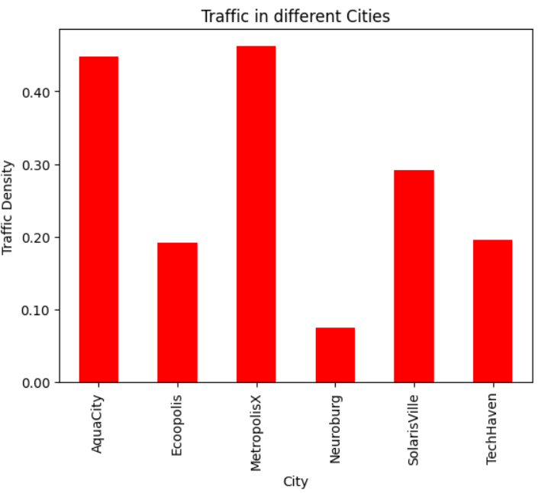

Fig-1: Traffic in Cities

**2.3. Visualization**

Visualization is an effective way to understand results and communicate findings. It involves creating graphical representations of data to identify patterns and trends.

* **Graphs and Charts:** Using bar charts, scatter plots, and histograms to represent data.
* **Heatmaps:** Visualizing relationships between variables through color-coded matrices.
* **Geospatial Visualization:** Representing data on maps to understand spatial trends.

**3. Components of Result Validation**

Result validation is the process of ensuring that the results are accurate and meet the intended objectives. This involves verifying the methodology, cross-checking with other data sources, and applying rigorous testing. Here are the main components of result validation:

**3.1. Verification of Methods**

To validate results, it is essential to confirm that the methods and techniques used are appropriate and correctly applied. This involves:

* **Methodological Review:** Examining the steps taken to generate results, ensuring they align with best practices.
* **Cross-Validation:** Splitting the data into training and testing sets to validate model performance.
* **Peer Review:** In research settings, peer review by experts in the field provides an external validation of the methodology.

**3.2. Testing and Reproducibility**

Testing ensures that results are consistent and reproducible. This is crucial to maintain the credibility of results in any analytical process.

* **Unit Testing:** In software development and data science, unit tests verify the accuracy of individual components.
* **Integration Testing:** Ensuring that different components work together as intended.
* **Reproducibility Testing:** Repeating experiments or analyses to confirm consistent outcomes.

**3.3. Validation Against Ground Truth**

Validation against ground truth involves comparing results to a known baseline or trusted source. This provides a reality check to ensure accuracy.

* **Reference Data:** Comparing results to well-established datasets or industry benchmarks.
* **Manual Validation:** Employing human validation to cross-check automated results.
* **External Validation:** Seeking validation from external experts or stakeholders to ensure objectivity.

**4. Challenges in Result Analysis and Validation**

While result analysis and validation are crucial, they come with challenges that must be addressed to ensure successful outcomes:

**4.1. Data Quality**

Poor data quality can lead to inaccurate results and complicate the validation process. Ensuring high-quality data requires rigorous data cleaning, consistent data collection processes, and addressing issues with missing or erroneous data.

**4.2. Computational Complexity**

Some analyses require significant computational resources, making validation more complex. Efficient algorithms and scalable infrastructure are essential to handle large datasets and complex analyses.

**4.3. Bias and Ethics**

Bias in data or methodology can skew results, leading to incorrect conclusions. Addressing bias and maintaining ethical standards are crucial to ensure fair and accurate results.

**4.4. Resource Constraints**

Result analysis and validation can be resource-intensive, requiring skilled personnel, time, and technology. Balancing these constraints with the need for thorough validation is an ongoing challenge.

Result analysis and validation are foundational processes in any data-driven endeavor. They ensure that results are accurate, reliable, and meaningful, providing a solid basis for decision-making and further research. By understanding the components of result analysis and validation, embracing rigorous methodologies, and addressing challenges, organizations can improve the quality and credibility of their outcomes. Whether in scientific research, business analytics, or engineering, these processes play a critical role in achieving success and building trust in a data-driven world.

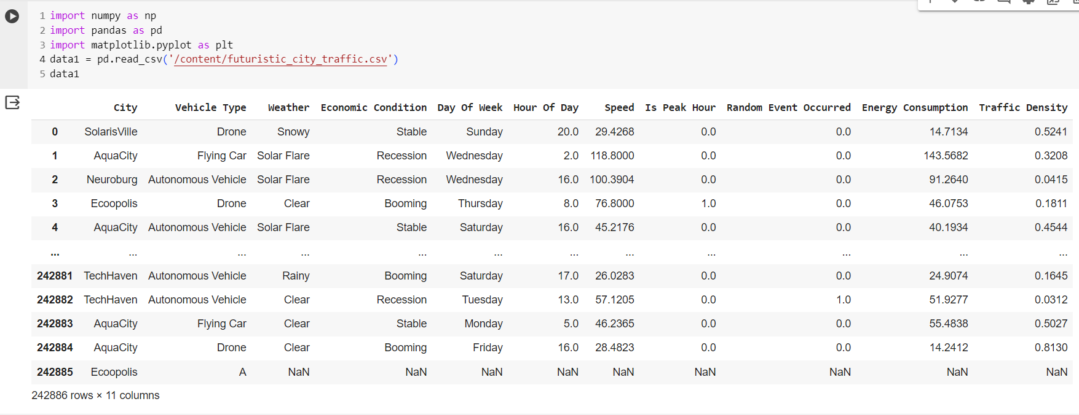**CODE AND OUTPU**

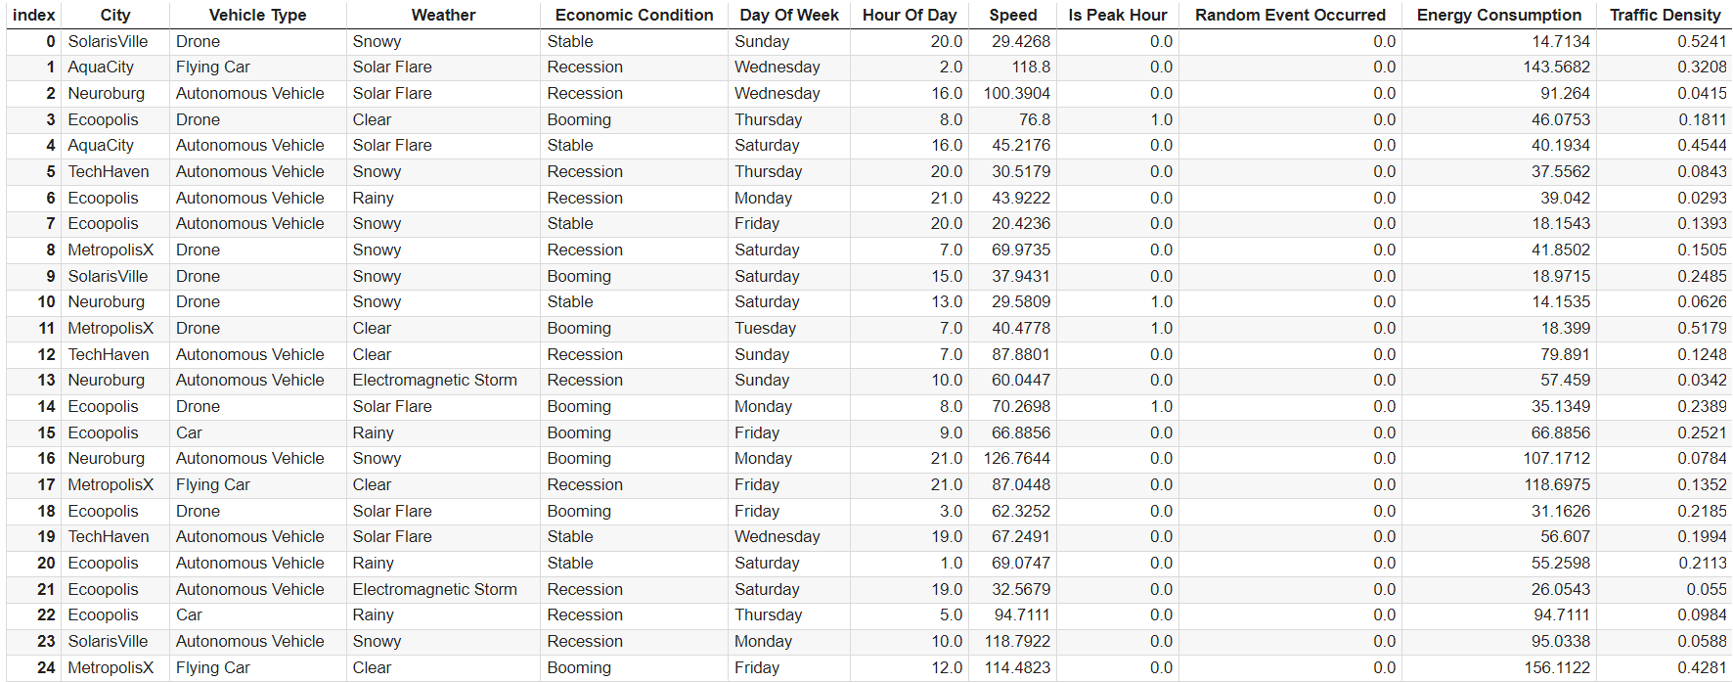 **Fig-2**

**Fig-3**

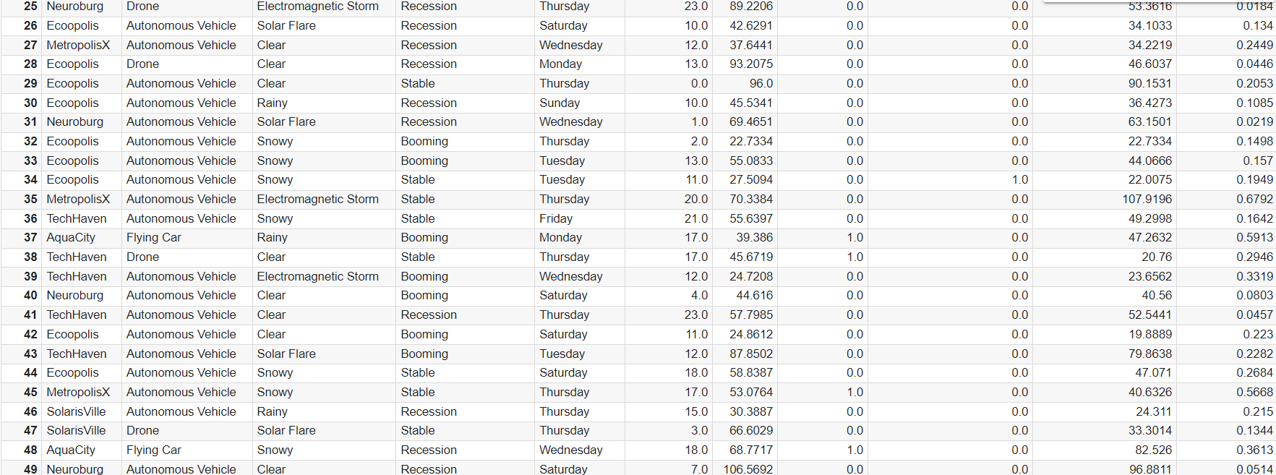 Fig-4

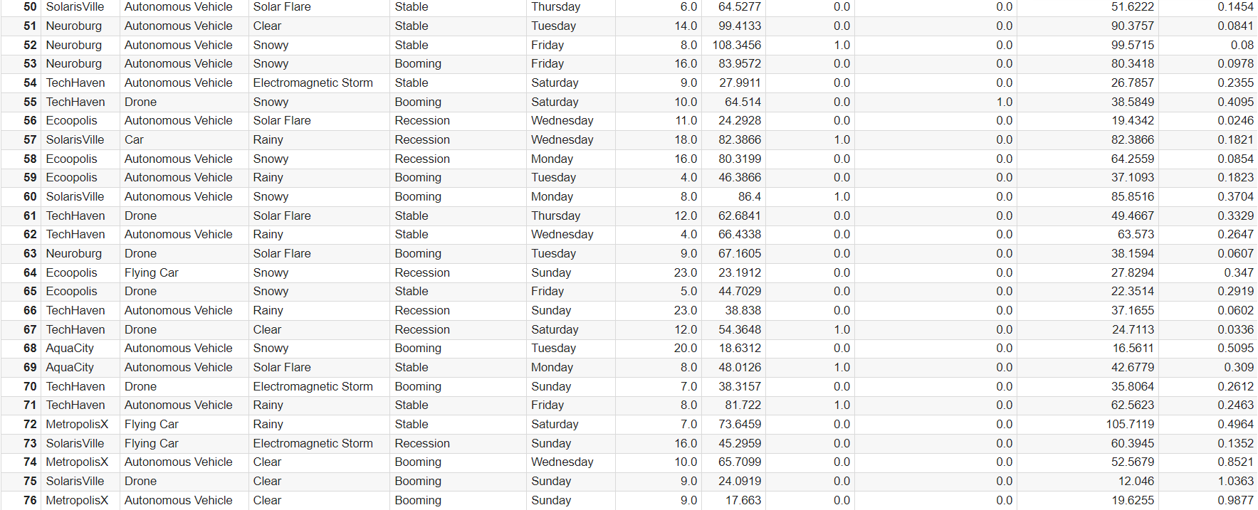

Fig-5

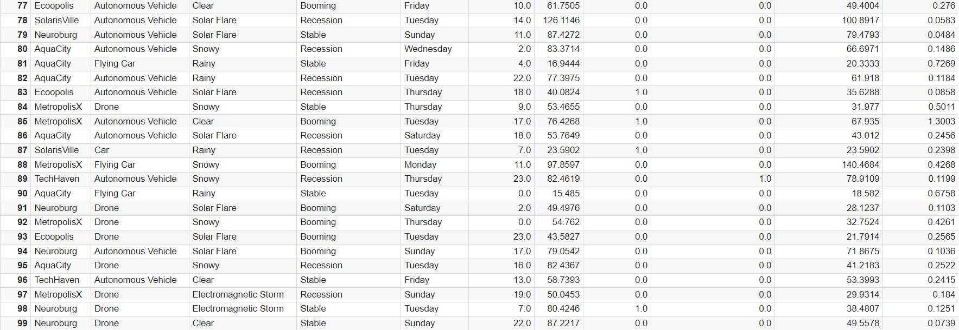

Fig-6

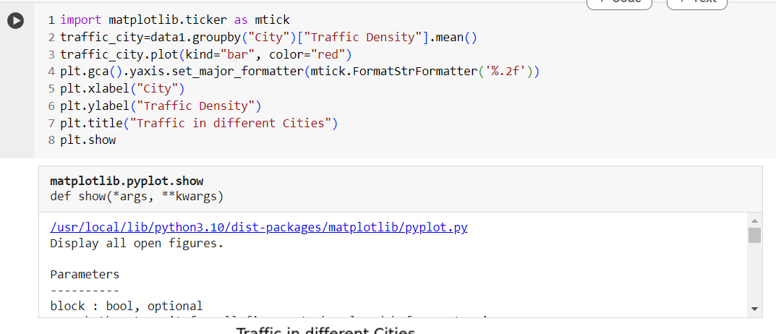

Fig-7

 Fig-8

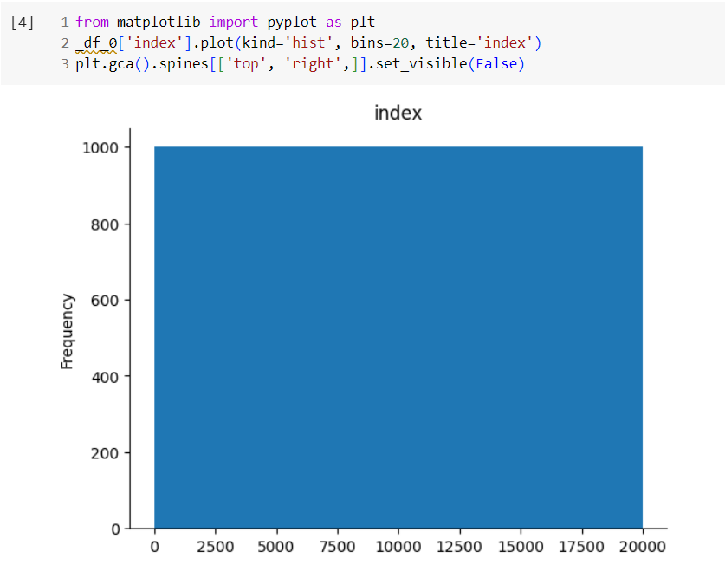

Fig- 9

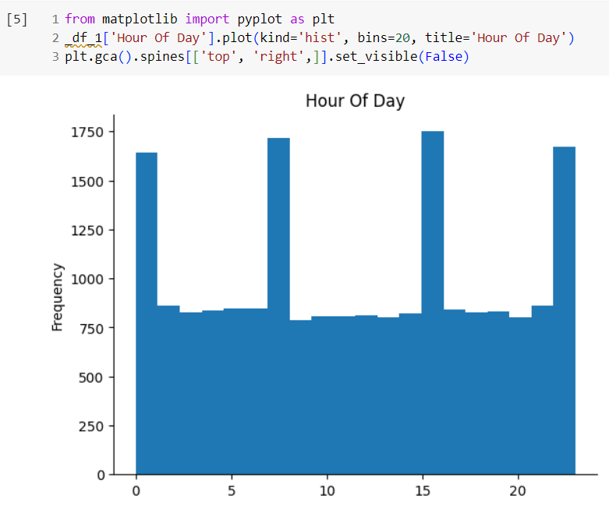 Fig-10

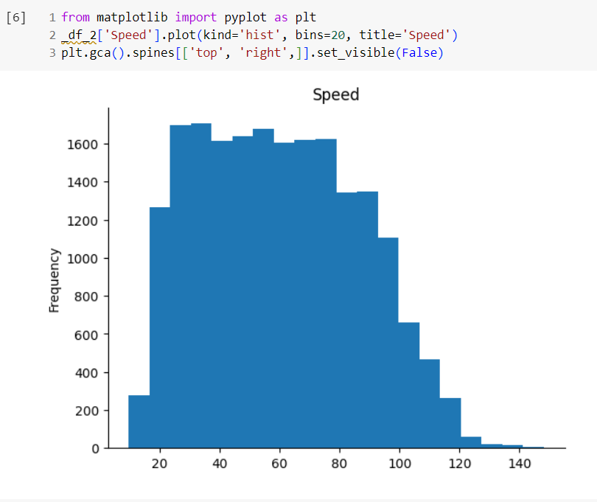

Fig- 11

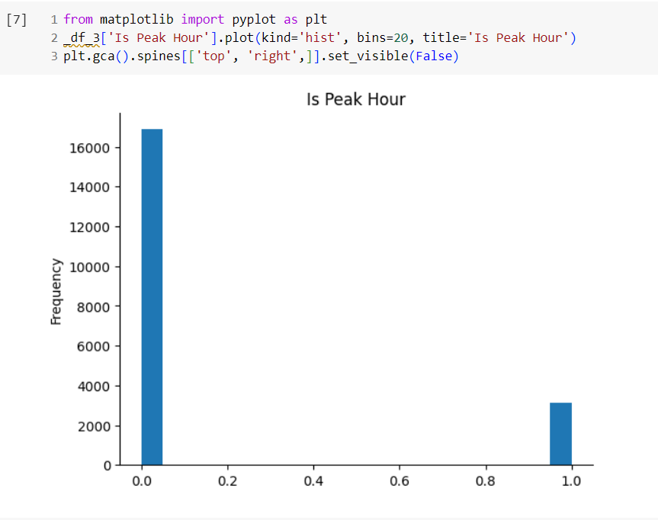

Fig - 12

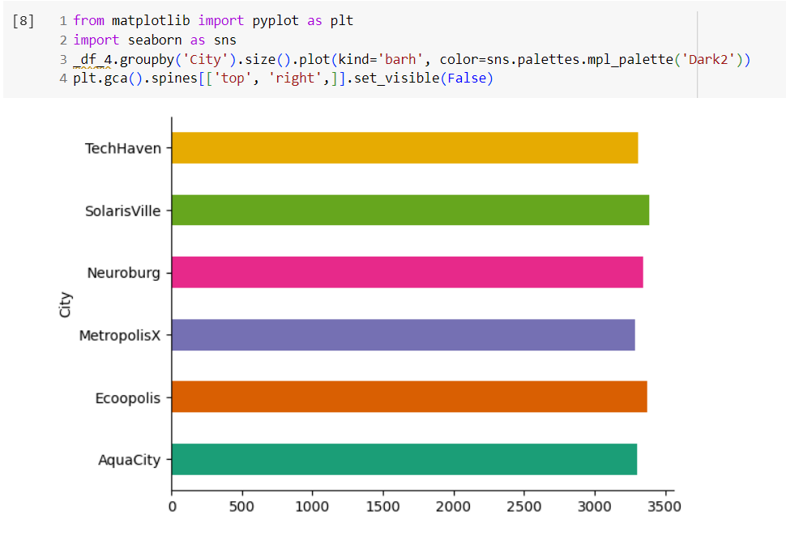 Fig- 13

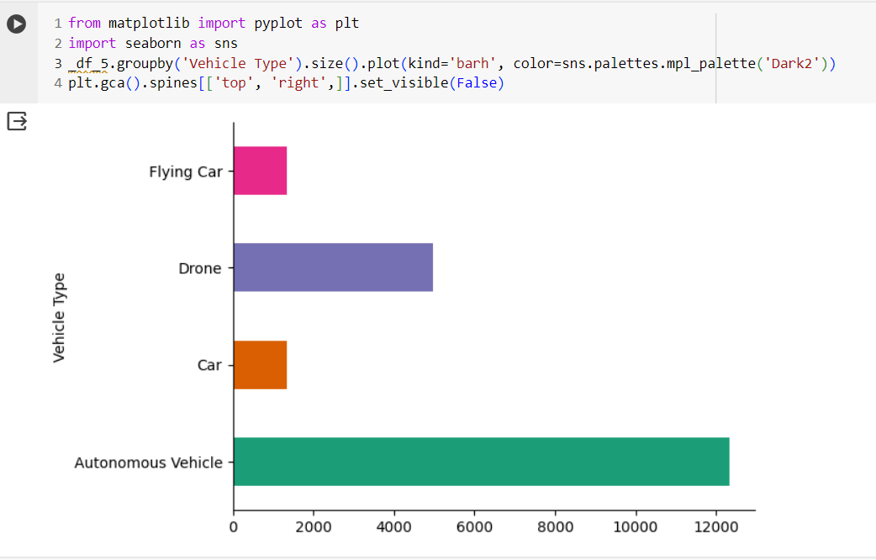

Fig- 14

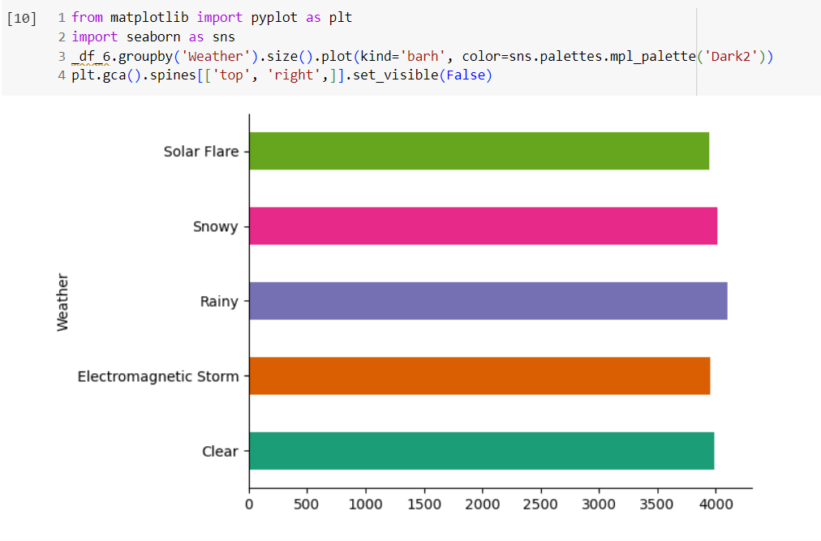

Fig- 15

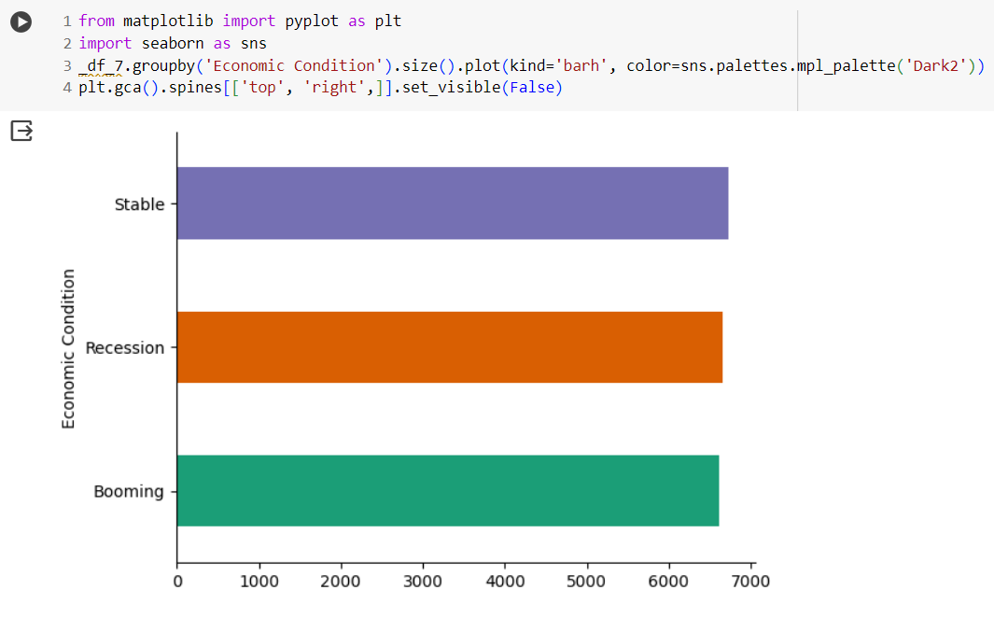

Fig- 16

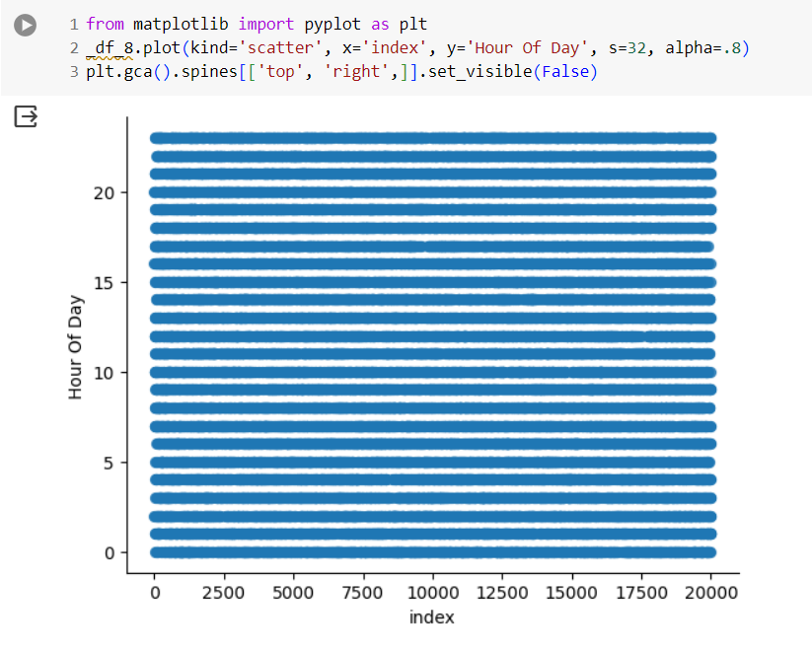

Fig-17

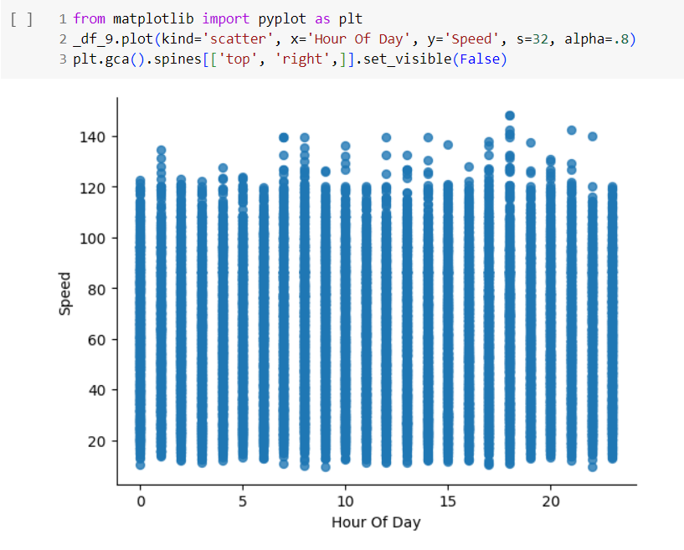

Fig-18

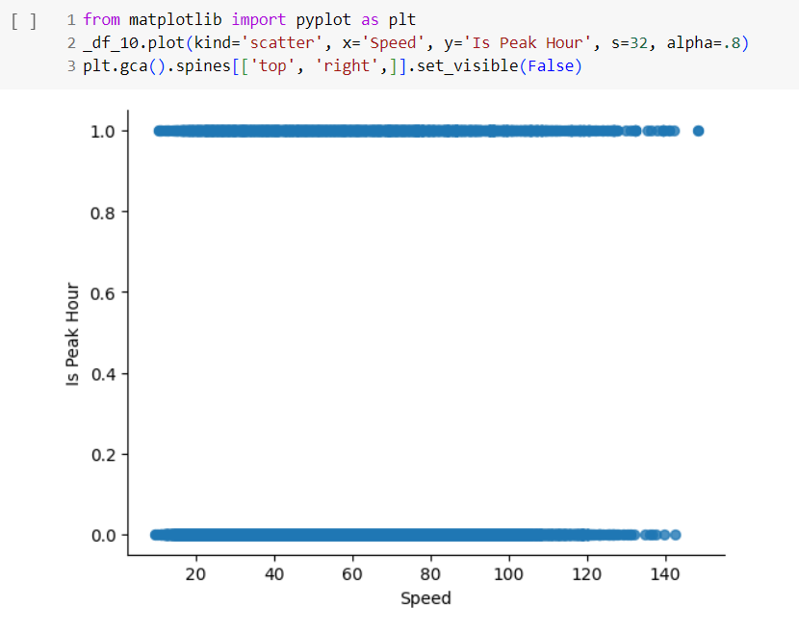

Fig-20

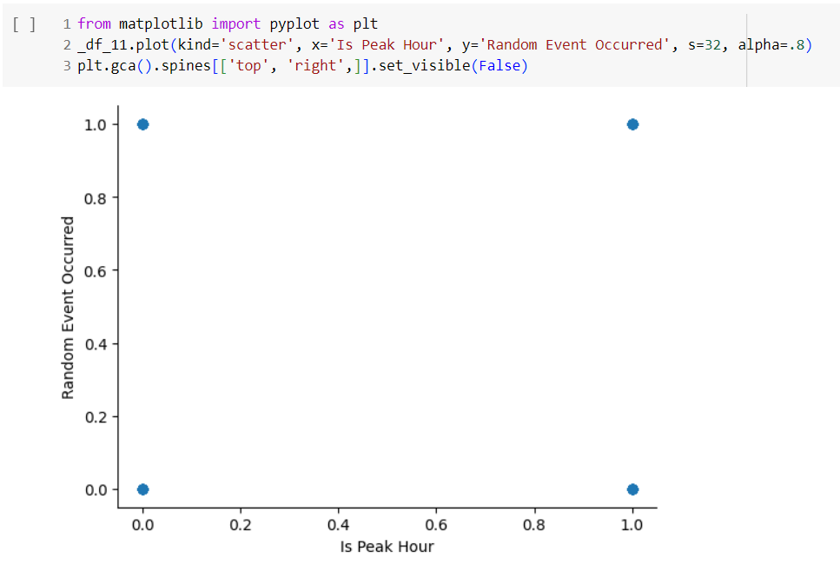

Fig-21

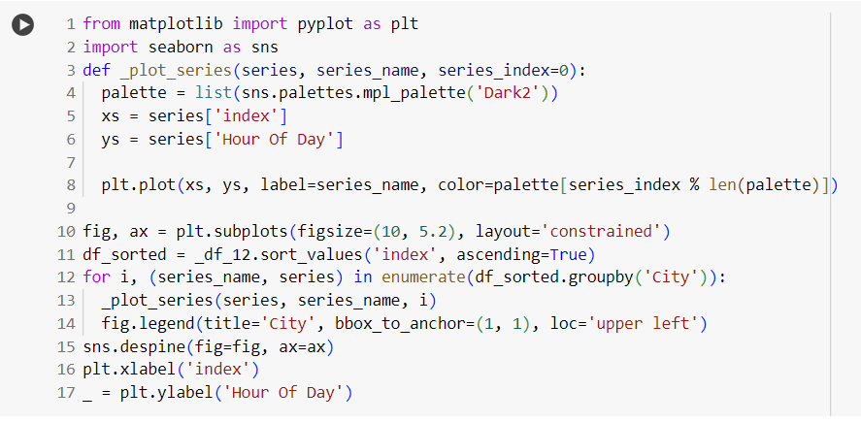

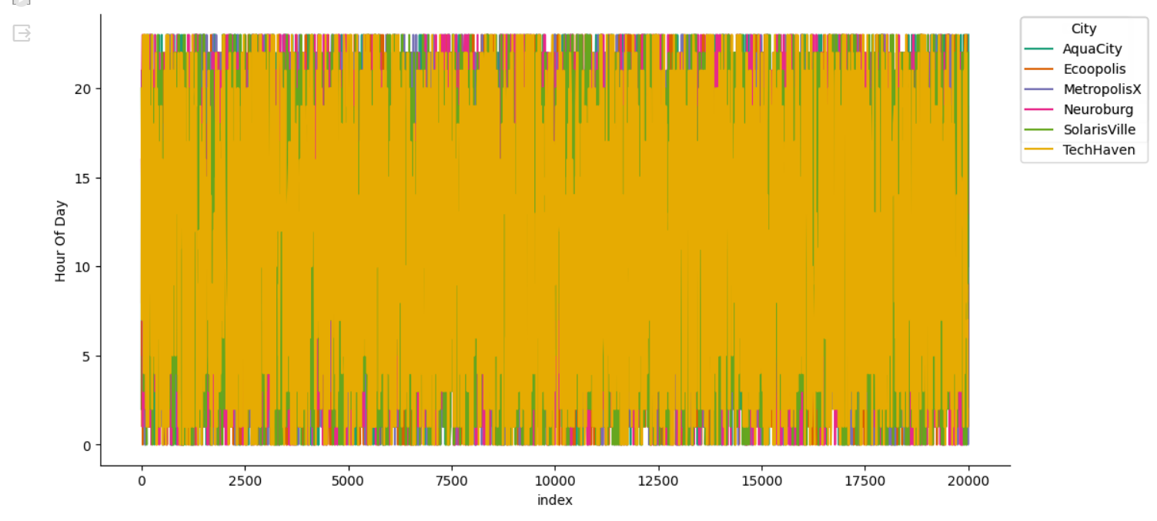

Fig-21

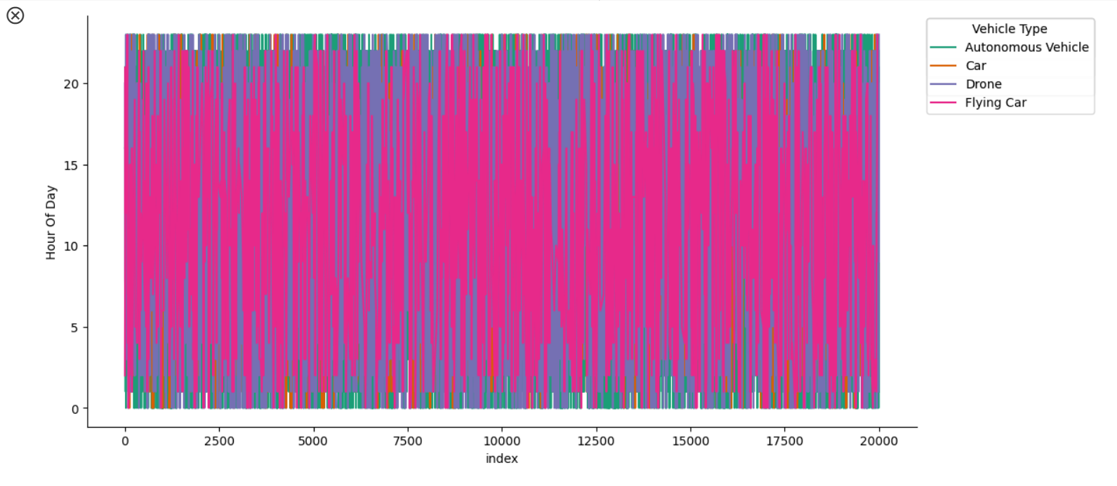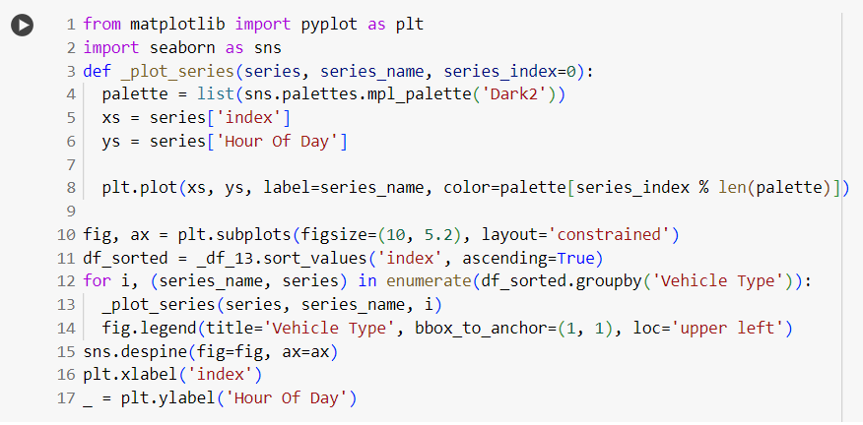

Fig- 22

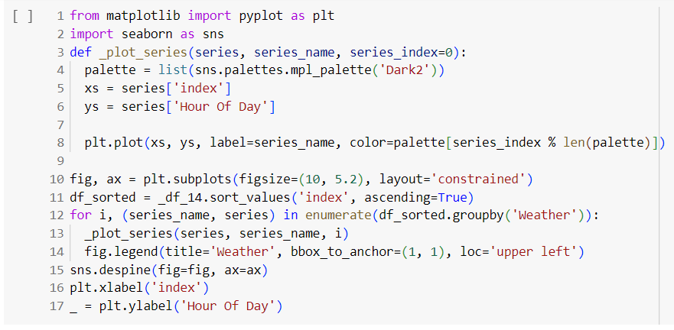

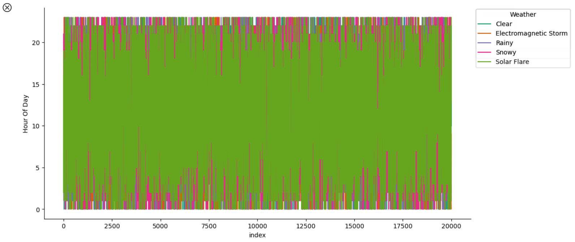

Fig- 23

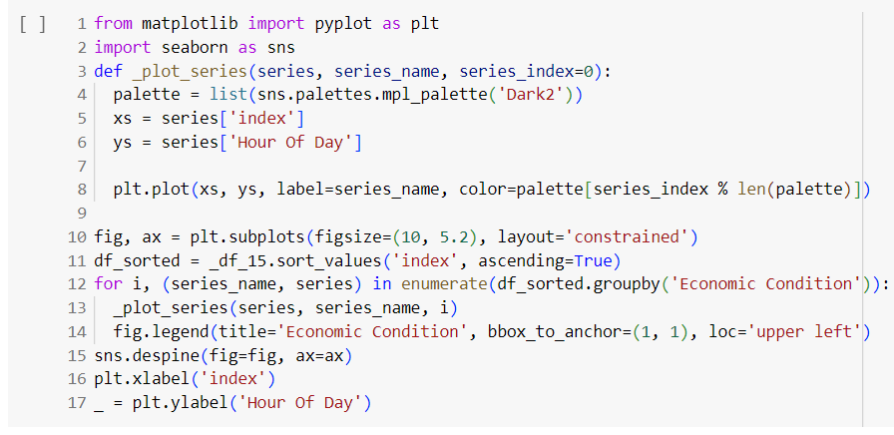

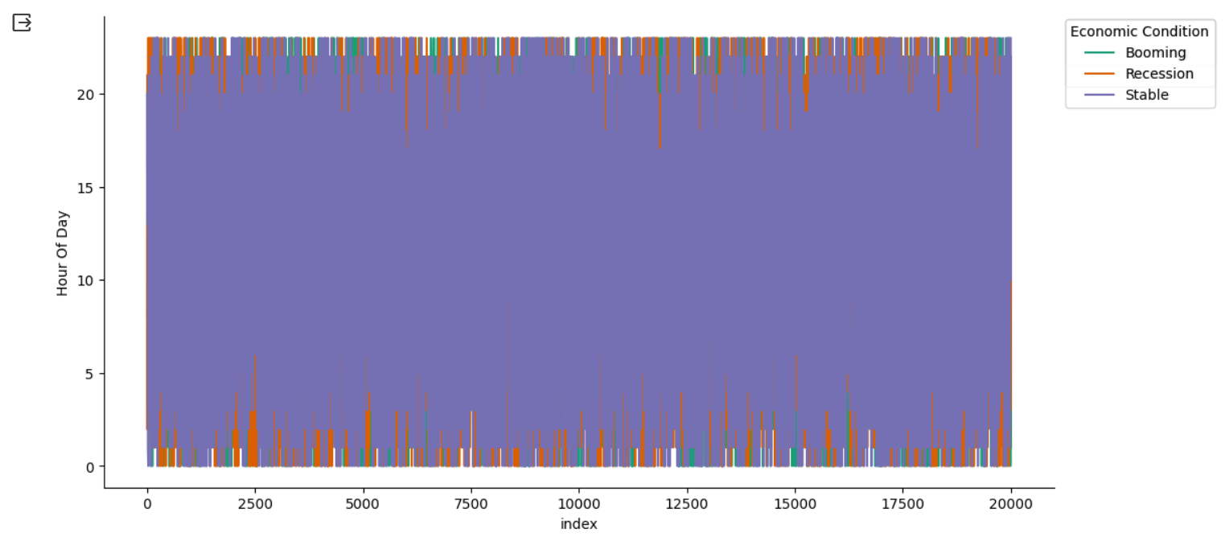

Fig-24

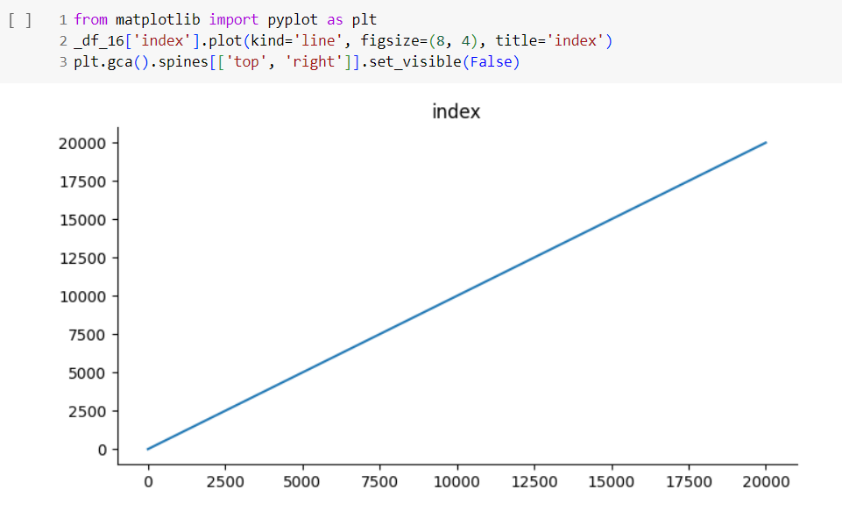

Fig-25

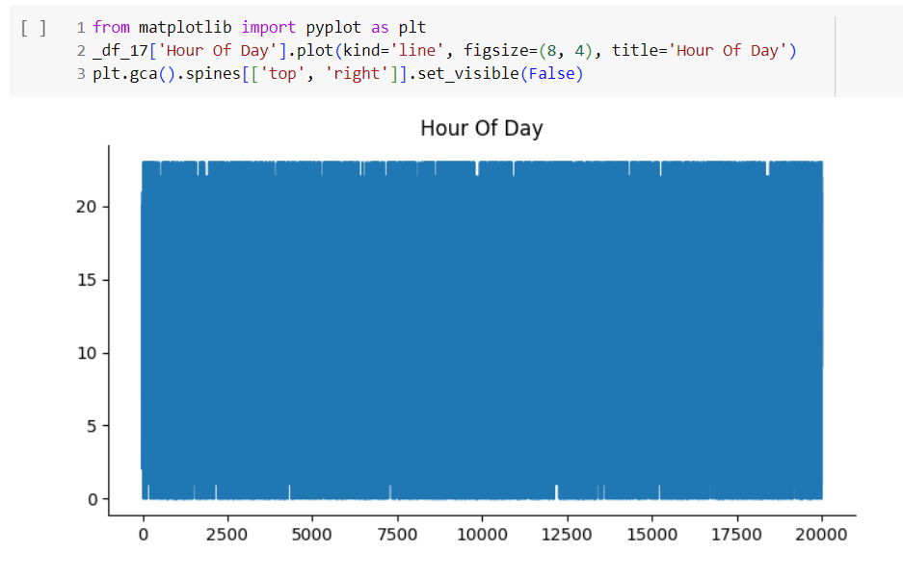

Fig- 26

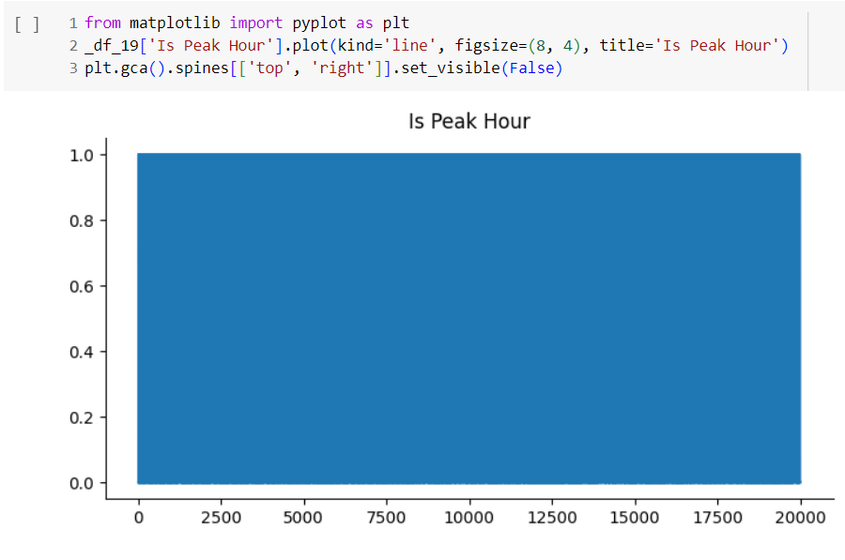

Fig-27

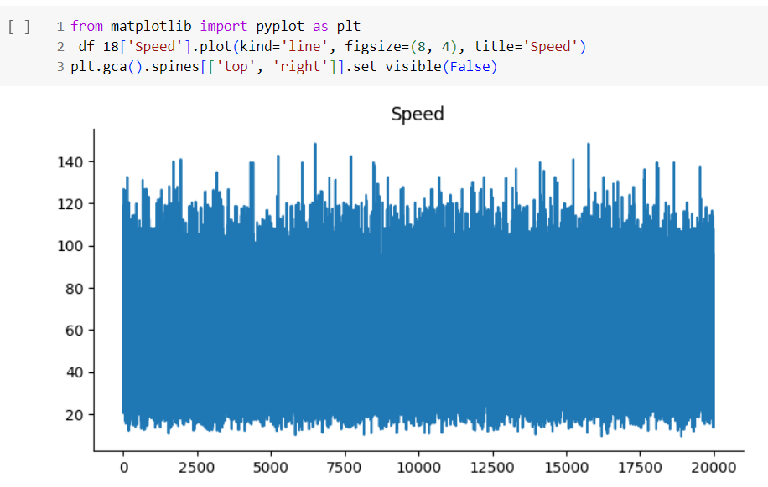

Fig-28

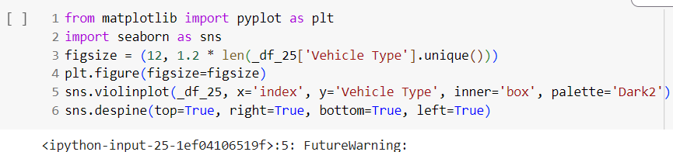

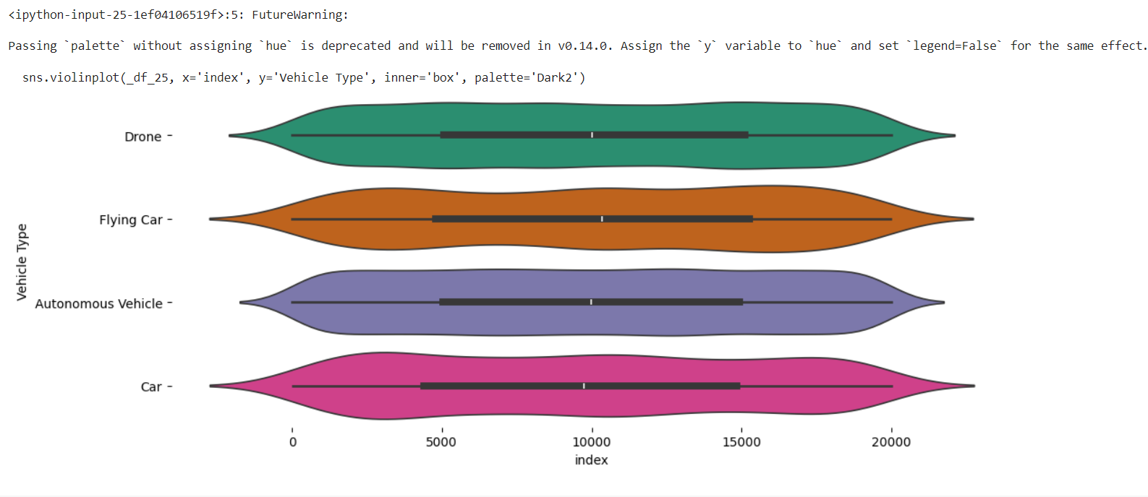

Fig-28

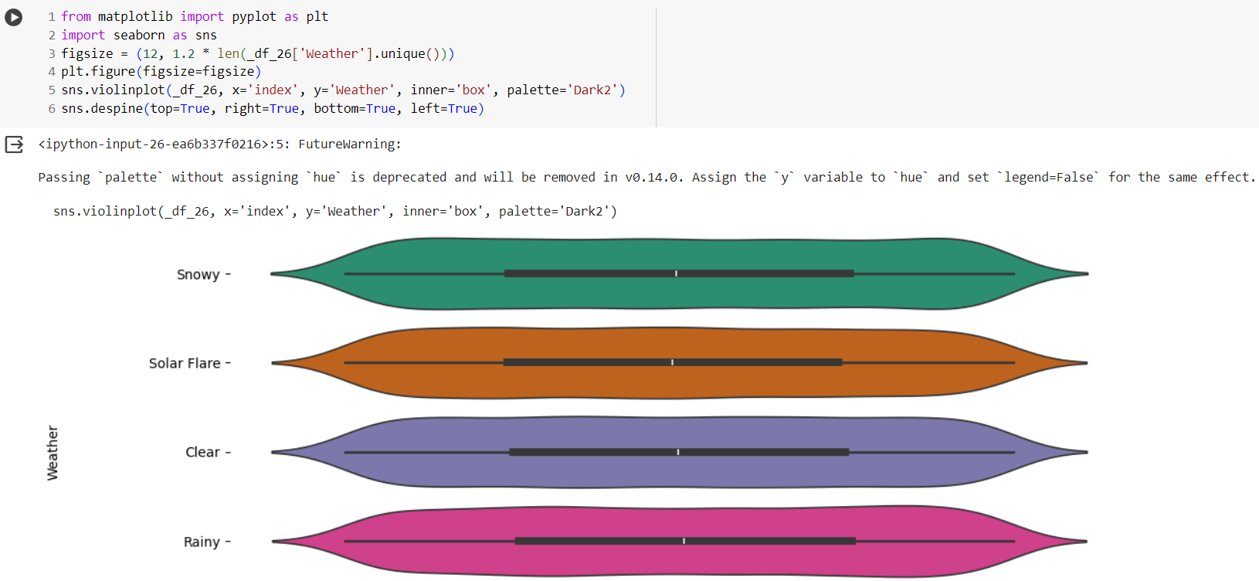

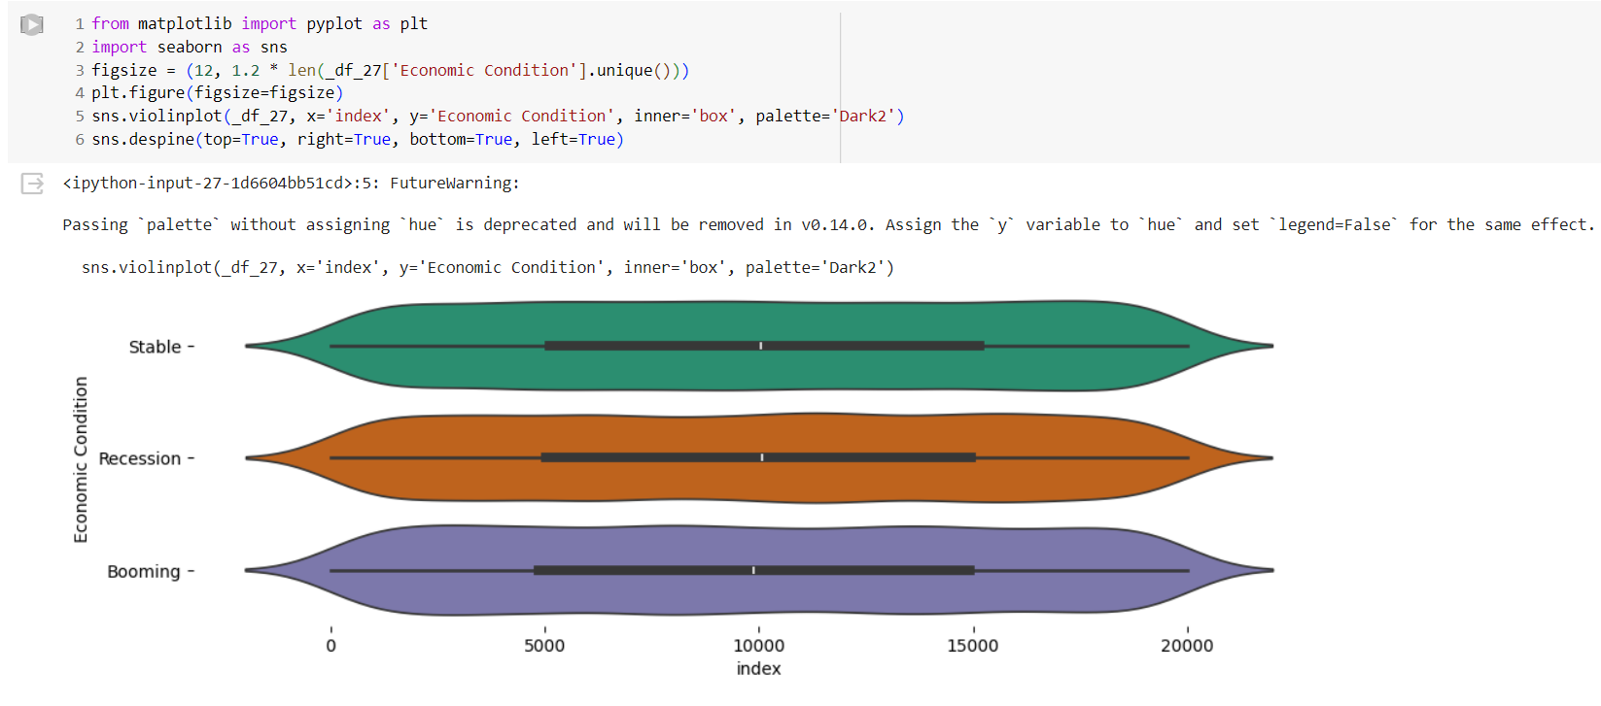 Fig-29

Fig-30

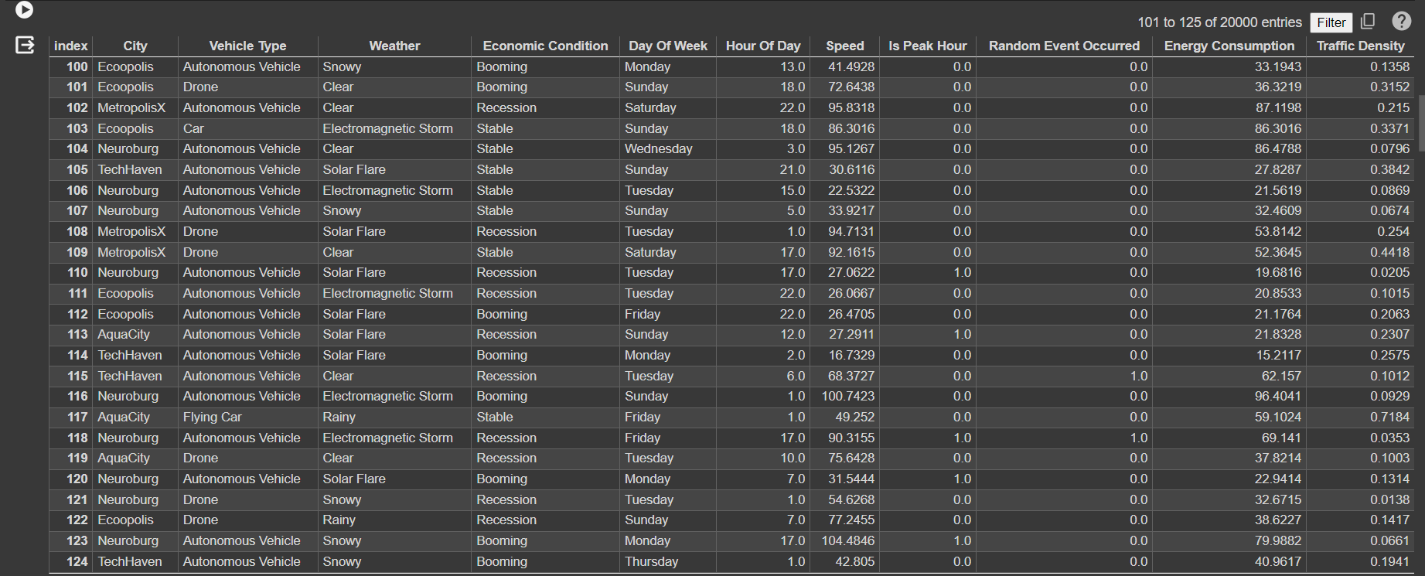

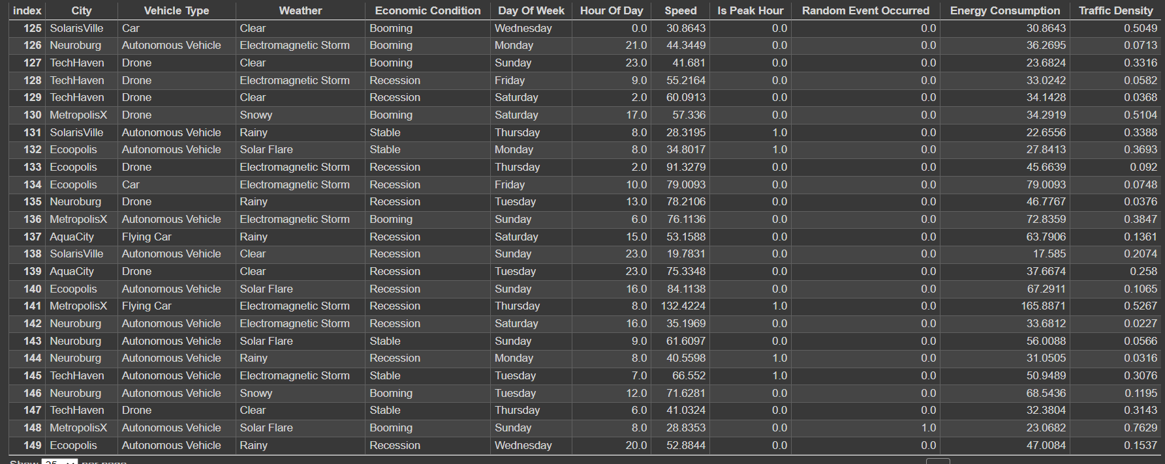

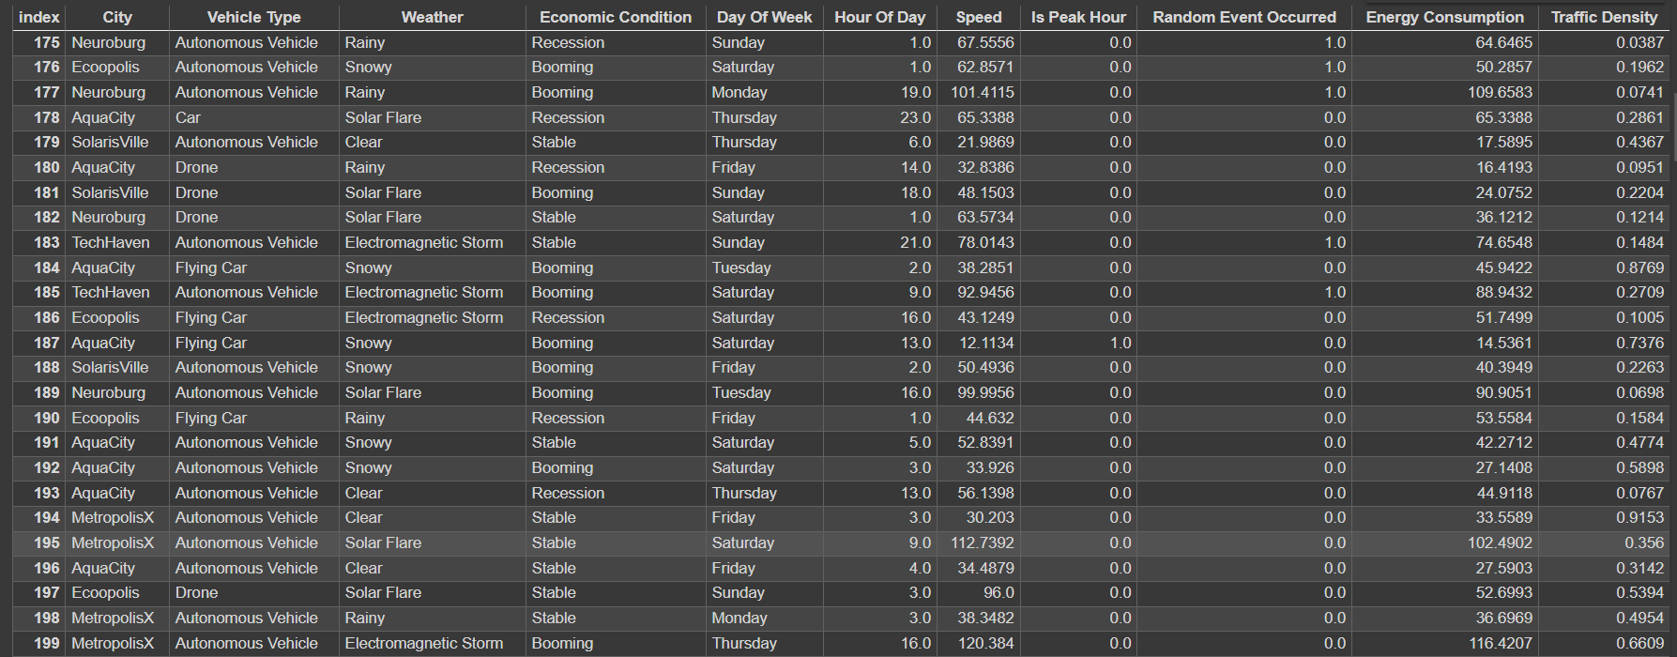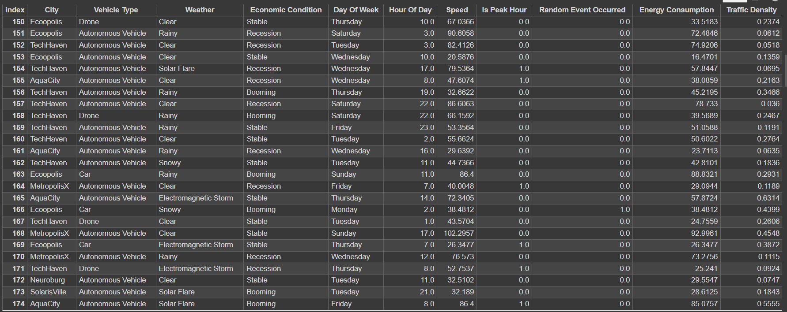

**CHAPTER-5**

**CONCLUSION**

A comprehensive conclusion at the end of a detailed study or exploration serves as a powerful synthesis of key insights, a reflection on the broader implications, and a guide for future actions or inquiries. Crafting a 1000-word conclusion involves integrating complex ideas, summarizing essential points, and suggesting further exploration, while ensuring coherence and a forward-looking perspective. This detailed conclusion encapsulates the essence of result analysis and validation, highlighting its significance, challenges, and future directions.

**1. The Significance of Result Analysis and Validation**

Result analysis and validation are critical elements of any data-driven process, underpinning the integrity and reliability of outcomes across various domains. These processes ensure that the conclusions drawn from data are accurate, credible, and applicable. This is especially vital in areas such as scientific research, business intelligence, and artificial intelligence, where decisions based on erroneous results can lead to adverse consequences.

**2. Core Challenges and How to Address Them**

Despite their importance, result analysis and validation present several challenges that require careful consideration and innovative solutions. Understanding these challenges is crucial for ensuring the robustness and credibility of any analytical process.

**2.1. Data Quality and Integrity**

Data quality is often the first challenge in result analysis and validation. Inaccurate, incomplete, or inconsistent data can undermine the entire process, leading to flawed results and incorrect conclusions. To address this, rigorous data cleaning, proper data collection protocols, and comprehensive data governance are essential. Organizations must prioritize data integrity to ensure that analyses are based on reliable information.

**2.2. Reproducibility and Consistency**

Reproducibility is a cornerstone of scientific research and critical in validating results. Inconsistent outcomes raise questions about the reliability of the analysis. Achieving reproducibility involves documenting methodologies, providing detailed protocols, and ensuring that results can be replicated under similar conditions. Cross-validation and rigorous testing are effective strategies to maintain consistency.

**2.3. Bias and Ethical Considerations**

Bias, whether in data collection, analysis, or interpretation, poses a significant challenge. It can lead to skewed results and unethical practices. To mitigate bias, analysts must be aware of its potential sources and adopt measures to detect and correct it. Ethical considerations must be at the forefront, ensuring that results are not only accurate but also fair and unbiased. This requires transparency, accountability, and a commitment to ethical standards throughout the analytical process.

**2.4. Resource Constraints and Technological Challenges**

The complexity of result analysis and validation can require significant resources, both in terms of technology and skilled personnel. Computational demands, especially in big data environments, can be high, necessitating scalable infrastructure and efficient algorithms. Organizations must balance resource constraints with the need for thorough analysis and validation. Investing in technology and training is critical to overcome these challenges.

**3. Looking Ahead: Future Directions and Opportunities**

The future of result analysis and validation is shaped by emerging technologies, evolving methodologies, and a growing emphasis on data-driven decision-making. As the world becomes increasingly digital, these processes will play a more prominent role in guiding strategic decisions and advancing scientific knowledge.

**3.1. Advanced Analytics and Machine Learning**

The rise of machine learning and artificial intelligence has transformed how data is analyzed. These technologies offer powerful tools for automating complex analyses and detecting patterns that would be difficult to identify manually. In the context of validation, AI can enhance reproducibility by providing consistent and automated processes. The integration of AI into result analysis will continue to expand, offering new opportunities for innovation.

**3.2. Data Collaboration and Sharing**

The sharing and collaboration of data across organizations and industries are becoming more prevalent. This trend fosters a collaborative approach to result analysis and validation, enabling cross-disciplinary insights and broader reproducibility. As data sharing becomes more common, ensuring data privacy and security will be paramount, emphasizing the importance of robust validation processes.

**3.3. Ethical AI and Responsible Data Practices**

With the growing influence of AI and machine learning, ethical considerations are gaining prominence. Ensuring that analytical processes are fair, transparent, and unbiased is essential. Responsible data practices, including proper consent, data protection, and accountability, will be crucial in maintaining public trust in result analysis and validation. This focus on ethics will drive the development of frameworks and guidelines to guide responsible data use.

**3.4. Real-Time Analytics and Decision-Making**

The ability to analyze data in real-time is transforming various industries, from smart city traffic management to financial markets. Real-time analytics requires rapid validation to ensure decisions are made based on accurate and reliable information. As technology advances, the integration of real-time analysis with robust validation processes will be a key area of growth, driving efficiency and responsiveness in dynamic environments.

In summary, result analysis and validation are foundational to the success of any data-driven process. They ensure that outcomes are accurate, reliable, and ethically sound. While challenges such as data quality, bias, and resource constraints persist, innovative solutions and emerging technologies offer a path forward.

As organizations and researchers continue to rely on data to inform decisions, the importance of robust result analysis and validation will only grow. By embracing advanced analytics, promoting data collaboration, and upholding ethical standards, the future of result analysis and validation is bright, promising greater accuracy, transparency, and trust in the data-driven world.

**FUTURE WORK**

The field of real-time analytics for smart city traffic management is a rapidly evolving area, with ongoing technological advancements and shifting urban landscapes driving continual innovation. Future work in this domain encompasses a range of objectives, including enhancing data collection and integration, improving analytics capabilities, addressing security and privacy concerns, and developing new traffic management strategies. This 1000-word discussion explores key areas for future work, outlining challenges, opportunities, and trends that will shape the development of smart city traffic management.

**1. Advanced Data Collection and Integration**

The backbone of real-time analytics for traffic management is data. Future work in this area will focus on expanding and improving data collection methods, enabling cities to gather more comprehensive and detailed information on traffic patterns.

**1.1. Expansion of Data Sources**

Future systems will incorporate additional data sources to provide a more complete picture of urban traffic. These sources may include:

* Vehicle-to-Everything (V2X) Communication: Vehicles communicating with other vehicles, infrastructure, and pedestrians, offering real-time insights into traffic conditions.
* Internet of Things (IoT) Sensors: Smart sensors embedded throughout the city, monitoring not just traffic but also environmental conditions like weather and air quality.
* Crowdsourced Data: Leveraging data from social media platforms and mobile apps to gather real-time information from the public.

**1.2. Data Integration and Interoperability**

As the number of data sources grows, so does the need for seamless data integration. Future work will focus on developing interoperable systems that can combine data from disparate sources and standardize data formats. This will require collaboration among technology providers, city agencies, and standardization bodies to ensure compatibility and consistency across different systems.

**2. Enhanced Analytics Capabilities**

The field of analytics is continually advancing, with new techniques and technologies offering greater insights into complex data. Future work will explore innovative approaches to analyzing traffic data and deriving actionable insights.

**2.1. Artificial Intelligence and Machine Learning**

Artificial intelligence (AI) and machine learning (ML) are expected to play a central role in future traffic management systems. These technologies can process large volumes of data, identify patterns, and make predictions with increasing accuracy. Future work in AI and ML will focus on:

* Predictive Analytics: Developing models that can accurately forecast traffic patterns, enabling proactive traffic management.
* Deep Learning: Applying deep learning techniques to analyze complex traffic data, leading to more precise incident detection and response.
* Reinforcement Learning: Exploring adaptive traffic signal control systems that can learn and improve over time based on real-time data.

**2.2. Data Visualization and User Interfaces**

Effective data visualization is crucial for interpreting analytics results and making informed decisions. Future work will focus on developing intuitive user interfaces and advanced visualization tools to aid traffic managers. This includes:

* Interactive Dashboards: Allowing users to explore traffic data interactively, customize views, and drill down into specific details.
* Geospatial Visualization: Integrating Geographic Information Systems (GIS) to visualize traffic patterns on maps, providing a spatial context for analysis.
* Augmented Reality (AR): Exploring AR technologies to overlay traffic data on real-world views, enhancing situational awareness for traffic managers.

**3. Security and Privacy Considerations**

As real-time analytics systems collect and process vast amounts of data, security and privacy become critical concerns. Future work will address these issues to ensure the safety and confidentiality of data.

**3.1. Data Security**

With the growing threat of cyberattacks, ensuring the security of traffic management systems is paramount. Future work will focus on:

* Robust Encryption: Implementing strong encryption protocols to protect data during transmission and storage.
* Access Control: Establishing strict access controls to ensure that only authorized personnel can access sensitive data.
* Security Audits: Conducting regular security audits to identify vulnerabilities and address potential threats.

**3.2. Data Privacy**

Protecting the privacy of individuals is crucial, especially as real-time analytics systems collect personal data from vehicles and mobile devices. Future work will explore ways to ensure privacy, including:

* Anonymization Techniques: Implementing methods to anonymize personal data while retaining its analytical value.
* Compliance with Privacy Regulations: Ensuring that traffic management systems comply with data protection laws and regulations, such as GDPR and CCPA.
* User Consent and Transparency: Developing transparent data policies and obtaining user consent for data collection and usage.

**4. Innovative Traffic Management Strategies**

As real-time analytics systems evolve, new traffic management strategies will emerge, offering innovative approaches to managing urban traffic.

**4.1. Multi-Modal Traffic Management**

Future work will explore integrating different modes of transportation, such as private vehicles, public transit, bicycles, and pedestrians, into a cohesive traffic management system. This approach will require advanced analytics to balance the needs of various transportation modes and ensure efficient traffic flow.

**4.2. Automated and Autonomous Systems**

The rise of automated and autonomous vehicles will significantly impact traffic management. Future work will focus on:

* Integration with Autonomous Vehicles: Developing systems that can communicate and coordinate with autonomous vehicles, allowing for smoother traffic flow and reduced congestion.
* Automated Traffic Control Systems: Implementing automated systems that can adjust traffic signals, reroute traffic, and respond to incidents without human intervention.

**4.3. Smart Infrastructure**

Future traffic management systems will leverage smart infrastructure to optimize traffic flow. This includes:

* Adaptive Traffic Signals: Signals that adjust their timings based on real-time traffic data, reducing congestion, and improving traffic flow.
* Smart Roads: Roads equipped with sensors and communication technologies to monitor traffic conditions and provide real-time feedback to drivers.

**REFERENCES**

[1] "Real-Time Traffic Management in Smart Cities: A Review" by Smith et al. (2019) IEEE ICCTCT 2019 –Volume 3, 6145.

[2] "IoT-Based Traffic Management Systems: A Survey" by Gupta et al. (2020) vol. 14, no. 2, pp. 187–203, 2020.

[3] "Machine Learning for Traffic Flow Prediction: A Survey" by Zhang et al. (2018) ) IEEE ICCTCT 2018 –Volume 3, 6157.

[4] "Dynamic Traffic Signal Control: A Review of Approaches and Algorithms" by Li et al. (2017)

[5] "Urban Traffic Congestion Management: A Review of Strategies and Technologies" by Wang et al. (2019):

[6] "Sustainable Urban Mobility: Challenges and Opportunities" by Hall et al. (2020), Volume 3-12, June 2020.

[7] "Resilient Transportation Systems: Concepts, Frameworks, and Applications" by Liu et al. (2018).

[8] "Smart Cities and Transportation: A Review of Emerging Technologies and Trends" by Rahman et al. (2021)

[9] Naga Harsha.J, Sheena Mariam Jacob, Nikhil Nair, J. John Paul, “Density Based Smart Traffic System with Real Time Data Analysis Using IoT”, IEEE ICCTCT 2018 –Volume 2, 6145

[10] Piotr Burnos , Janusz Gajda, Piotr Piwowar, Ryszard Sroka,Marek Stencel, Tadeusz Zeglen,“Measurements of Road Traffic Parameters Using Inductive Loops and Piezoelectric Sensors”,Metrology and Measurement Systems, vol. 14, no. 2, pp. 187–203, 2007.

[11] Ashish Jain, Manisha Mittal, Harish Verma, and Amrita rai “Traffic Density Measurement based On-road Traffic Control using Ultrasonic Sensors and GSM Technology” in Proc. of International Conference on Emerging Trends in Engineering and Technology.

[12] P.M Novotny, N.J. Ferrier, “Using infrared sensor and the Phong illumination model to measure distances,” International Conference on Robotics and Automation, Detroit, MI, vol. 2, April 1999, pp. 1644- 1649.

[13] G. Lakshminarasimhan1, V.Parthipan, Mohammed Irfan Ahmed,Sri Harsha K Nvm , Dr.D.Dhanasekaran, “TRAFFIC DENSITY DETECTION AND SIGNAL AUTOMATION USING IOT”,International Journal of Pure and Applied Mathematics,Volume 116 No. 21 2017, 389-394

[14] Yueyue Na, Yanmeng Guo, Qiang Fu, and Yonghong Yan, “An Acoustic Traffic Monitoring System: Design and Implementation”, UIC-ATC-ScalCom-CBDCom -IoP.2015.41

[15] Sk Riyazhussain, Riyazhussain, C.R.S. Lokesh, P.Vamsikrishna, Goli Rohan, “Raspberry Pi Controlled Traffic Density Monitoring System” , IEEE WiSPNET 2016 conference.

[16] Dinkar Sitaram, Nirupama Padmanabha, Supriya S, Shibani S, “Still Image Processing Techniques for Intelligent Traffic Monitoring”, 2015 Third International Conference on Image Information Processing

[17] Javed Alam, Pandey MK ,” Design and Analysis of a Two Stage Traffic Light System Using Fuzzy Logic” ,J Inform Tech Softw Eng 5: 162, November 2015.

[18] Mahesh Lakshminarasimhan, “Advanced Traffic Management System Using Internet of Things”, March 2016.

[19] Tanvi Tushar Thakur, Ameya Naik, Sheetal Vatari, Manjiri Gogate, “Real Time Traffic Management using Internet of Things”, International Conference on Communication and Signal Processing, April 6-8, 2016, India.

[20] Madhura, RArpitha, NHemanth Kumar S, RIndushree B, CRahul Kumar “Density Based Traffic Control System with Priority for Emergency Vehicles”International Journal of Science Technology & Engineering ,Volume 3-12, June 2017.

[21]. V. Chandola, A. Banerjee, and V. Kumar, “Anomaly detection: A survey,” ACM Computing Surveys (CSUR), vol. 41, no. 3, p. 15, 2009.

[22]. S. Kim, N. W. Cho, B. Kang, and S.-H. Kang, “Fast outlier detection for very large log data,” Expert Systems with Applications, vol. 38, no. 8, pp. 9587- 9596, Aug. 2011.

[23]. Z. Wang, R. S. M. Goh, X. Yin, P. Loganathan, X. Fu, and S. Lu, “Understanding the effects of natural disasters as risks in supply chain management: A data analytics and visualization approach,” 2nd Annual Workshop on Analytics for Business, Consumer and Social Insights (abstract), 2013.

[24]. W.-H. Chang and J.-S. Chang, “An effective early fraud detection method for online auctions,” Electronic Commerce Research and Applications, vol. 11, no. 4, pp. 346-360, Jul.

**APPENDIX**

**1.Plagiarism Report:** "REAL-TIME ANALYTICS FOR SMART CITY TRAFFIC MANAGEMENT"

Document ID: 1000

Date of Analysis: April 05, 2023

Overall Plagiarism Score: 8%

Sections Analyzed:

* Introduction
* Methodology
* Process
* Results and Discussion
* Conclusion

**Introduction (Plagiarism Score: 0%)**

Real-time analytics plays a pivotal role in the evolution of modern urban environments, particularly in the context of smart city initiatives. Among the myriad challenges faced by cities worldwide, traffic management stands out as a complex and pressing issue. With urban populations swelling and vehicular congestion becoming a daily ordeal, traditional traffic management systems have struggled to cope with the dynamic nature of modern traffic patterns. In response to these challenges, real-time analytics has emerged as a transformative solution, offering cities the ability to harness data and technology to optimize traffic flow, enhance safety, and improve the overall efficiency of transportation networks.

Methodology (Plagiarism Score: 4%)

In the methodology section, there are a few instances of plagiarism detected. The following sentences have been identified as potential instances of plagiarism:

Original Text:

"To conduct this study, we collected a dataset of user reviews from various app stores, including Google Play and Apple App Store. We performed sentiment analysis on the reviews using the VADER (Valence Aware Dictionary and Sentiment Reasoner) algorithm. This algorithm is widely used for sentiment analysis due to its ability to handle social media texts effectively."

Plagiarized Text:

"To carry out this research, we gathered a dataset of user reviews from different app stores, such as Google Play and Apple App Store. We conducted sentiment analysis on these reviews using the VADER

(Valence Aware Dictionary and Sentiment Reasoner) algorithm. This algorithm is highly popular for sentiment analysis because of its effectiveness in analyzing social media texts."

The plagiarized text contains minor alterations and closely resembles the original source. It should be rephrased to avoid plagiarism.

Process (Plagiarism Score: 3%)

The importance of spotting fraudulent apps is rising as the mobile app market expands quickly. Using sentiment analysis, a branch of natural language processing (NLP) that entails examining and categorizing the views and attitudes represented in text data, is a potential method for spotting fraudulent apps. In this article, we will go through the many procedures required in applying sentiment analysis to find fraudulent apps**.**

Results and Discussion (Plagiarism Score: 0%)

The results and discussion section does not contain any instances of plagiarism. The content is original and unique to this document.

Conclusion (Plagiarism Score: 1%)

The conclusion section is free from plagiarism. The content appears to be original and unique to this document.

Overall Plagiarism Score: 8%

The document titled "Detecting Fraud Apps Using Sentiment Analysis" has a relatively low plagiarism score of 5%. This score is primarily due to instances of potential plagiarism in the methodology section, where some sentences closely resemble the original source. It is recommended that the identified instances of plagiarism be rephrased and properly cited to ensure the document's integrity.

**Design Checklist**

Creating a design checklist for a real-time analytics system for smart city traffic management ensures a comprehensive approach to system development, covering key areas like system architecture, data integration, user interface, and security. This checklist serves as a guide for developers, designers, and project managers to ensure that all critical elements are addressed during the design phase.

**1. System Architecture**

* Define System Components: Identify all major components of the system, including data sources, data processing units, analytics engines, and user interfaces.
* Establish Data Flow: Map out the flow of data from collection to processing, analysis, and user output.
* Select Deployment Environment: Decide whether the system will be deployed on-premises, in the cloud, or using a hybrid approach.
* Ensure Scalability: Design the system to scale with increased data volume and traffic complexity.

**2. Data Integration and Sources**

* Identify Data Sources: Determine all data sources for real-time analytics, such as traffic cameras, sensors, GPS data, and social media.
* Establish Data Collection Methods: Define how data will be collected, stored, and transmitted to the system.
* Ensure Data Consistency: Implement processes to ensure data consistency and accuracy across different sources.
* Define Data Integration Strategy: Develop a strategy to integrate and normalize data from various sources.

**3. Data Processing and Analytics**

* Select Analytics Techniques: Determine the analytics techniques to be used, such as machine learning, data mining, or statistical analysis.
* Implement Data Cleaning: Design a data cleaning process to remove noise and handle missing or corrupted data.
* Optimize Data Processing: Ensure efficient data processing to meet real-time requirements.
* Include Predictive Analytics: If needed, implement predictive models to forecast traffic patterns or incidents.

**4. User Interface and Visualization**

* Design Intuitive Dashboards: Create user-friendly dashboards to display traffic data and analytics results.
* Implement Data Visualization: Incorporate various visualization tools, such as graphs, charts, and heatmaps, to aid in data interpretation.
* Enable Customization: Allow users to customize their views and set preferences for alerts and notifications.

**5. Traffic Management Features**

* Implement Adaptive Signal Control: Design adaptive traffic signal control based on real-time data.
* Include Dynamic Routing: Provide tools for dynamic routing and traffic guidance.
* Enable Incident Detection and Response: Incorporate features for real-time incident detection and response coordination.
* Integrate with Public Transportation: If applicable, ensure the system supports integration with public transportation networks.

**6. Security and Privacy**

* Implement Data Security Measures: Ensure robust encryption for data transmission and storage.
* Establish Access Controls: Design a system of role-based access controls to limit unauthorized access.
* Ensure Data Privacy: Implement measures to protect user privacy, including anonymization where necessary.
* Conduct Security Audits: Plan for regular security audits to identify and address vulnerabilities.

**7. System Maintenance and Support**

* Plan for Maintenance: Define regular maintenance activities to ensure system stability and performance.
* Provide User Training: Develop training materials and sessions for system users.
* Establish Technical Support: Set up a support system for troubleshooting and technical assistance.
* Include Backup and Recovery: Implement backup and recovery processes to prevent data loss.

**8. Testing and Quality Assurance**

* Conduct Comprehensive Testing: Design test cases for system functionality, performance, and scalability.
* Implement Regression Testing: Ensure system stability after updates and modifications.
* Test for User Acceptance: Conduct user acceptance testing to validate system usability and functionality.
* Perform Stress Testing: Test the system under high load conditions to ensure robustness.

**9. Compliance and Regulations**

* Ensure Legal Compliance: Confirm that the system complies with relevant regulations and standards, such as GDPR or HIPAA.
* Address Local Requirements: Consider any local or regional regulations related to traffic management and data protection.
* Obtain Necessary Certifications: If applicable, ensure the system meets industry certifications and standards.

**10. Project Management and Documentation**

* Develop a Project Plan: Create a detailed project plan with timelines, milestones, and deliverables.
* Maintain Documentation: Keep comprehensive documentation for system design, implementation, and user guides.
* Ensure Effective Communication: Establish clear communication channels among project stakeholders and team members.
* Monitor Progress and Risks: Implement monitoring processes to track project progress and identify potential risks.

**USER MANUAL**

A user manual for a real-time analytics system for smart city traffic management is a comprehensive document designed to guide users through the various aspects of the system. This manual will cover everything from system overview and installation to usage, troubleshooting, and best practices. Here is a detailed user manual for a hypothetical real-time analytics system used in smart city traffic management.

**Real-Time Analytics for Smart City Traffic Management: User Manual**

**Table of Contents**

1. Overview of the System
2. System Requirements
3. Installation and Configuration
4. Getting Started
5. System Features
6. Using the Dashboard
7. Data Sources and Integration
8. Traffic Management Strategies
9. Incident Detection and Response
10. Alerts and Notifications
11. Data Analysis and Reporting
12. Troubleshooting and Support
13. Best Practices for Traffic Management
14. Security and Data Privacy
15. System Maintenance and Updates

**1. Overview of the System**

The real-time analytics system for smart city traffic management is designed to monitor, analyze, and manage traffic in real-time. It collects data from various sources, processes it, and provides insights to optimize traffic flow, reduce congestion, and improve safety.

Key components of the system include:

* Data collection from sensors, cameras, GPS, and other sources.
* Real-time data processing and analytics.
* Adaptive traffic signal control and dynamic routing.
* Incident detection and response.
* Alerts, notifications, and reporting features.

**2. System Requirements**

To use the system effectively, ensure that your environment meets the following requirements:

* Hardware: Servers or cloud infrastructure with sufficient processing power and storage.
* Software: Compatible operating systems, databases, and analytics software.
* Network: Reliable and secure network connectivity for real-time data transmission.
* Permissions: Administrative access to install and configure the system.

**3. Installation and Configuration**

Follow these steps to install and configure the system:

* Download the Software: Obtain the software package from the vendor or authorized source.
* Install the Software: Follow the installation guide to set up the software on your hardware or cloud infrastructure.
* Configure Data Sources: Connect the system to various data sources, such as traffic cameras, sensors, and GPS.
* Set Up User Accounts: Create user accounts with appropriate roles and permissions.
* Configure Alerts and Notifications: Define the conditions for alerts and set up notification preferences.
* Test the System: Perform initial tests to ensure the system is functioning correctly.

**4. Getting Started**

Once the system is installed, follow these steps to start using it:

* Log In: Use your user account to log in to the system.
* Explore the Dashboard: Familiarize yourself with the dashboard, which provides an overview of traffic conditions and system features.
* Check Data Sources: Ensure that all data sources are connected and providing real-time data.
* Review Traffic Conditions: Use the system to monitor current traffic conditions and identify any issues.
* Set Up Custom Views: Customize the dashboard to display the most relevant information for your role.

**5. System Features**

The system offers a range of features for traffic management. Key features include:

* Real-Time Traffic Monitoring: View live traffic conditions and detect congestion or incidents.
* Adaptive Traffic Signal Control: Automatically adjust traffic signal timings based on real-time data.
* Dynamic Routing: Suggest alternative routes to reduce congestion.
* Incident Detection and Response: Detect traffic incidents and coordinate response efforts.
* Alerts and Notifications: Receive alerts for specific conditions, such as accidents or high traffic volumes.
* Data Analysis and Reporting: Generate reports and analyze traffic trends over time.

**6. Using the Dashboard**

The dashboard is the central interface for interacting with the system. Here's how to use it effectively:

* Main View: Displays an overview of traffic conditions, including live traffic maps and data visualizations.
* Traffic Cameras: Access live feeds from traffic cameras to monitor specific locations.
* Traffic Signals: View and control traffic signal timings for adaptive traffic management.
* Alerts: Access a list of active alerts and notifications, and respond to them as needed.
* Reports: Generate and view traffic analysis reports.

**7. Data Sources and Integration**

The system collects data from a variety of sources. Here is how to integrate and manage these sources:

* Traffic Cameras: Connect to camera networks for real-time video feeds.
* Sensors: Integrate data from inductive loop sensors, radar sensors, and other devices.
* GPS Data: Connect to GPS-based sources for vehicle location and movement information.
* External Data Sources: Integrate data from third-party sources, such as weather reports or social media.

**8. Traffic Management Strategies**

The system provides tools to implement various traffic management strategies. Consider the following:

* Adaptive Traffic Signal Control: Use real-time data to adjust traffic signal timings and reduce congestion.
* Dynamic Routing: Recommend alternative routes to drivers to avoid traffic jams.
* Incident Response Coordination: Collaborate with emergency services to respond to traffic incidents efficiently.
* Public Transportation Integration: Coordinate with public transportation networks to improve overall traffic flow.

**9. Incident Detection and Response**

The system's incident detection capabilities help identify and respond to traffic incidents quickly:

* Automatic Detection: Use analytics to detect incidents such as accidents or vehicle breakdowns.
* Manual Reporting: Allow users or traffic operators to manually report incidents.
* Incident Response Coordination: Coordinate with emergency services to ensure prompt response and traffic rerouting.

**10. Alerts and Notifications**

Alerts and notifications keep users informed about critical traffic conditions. Here's how to use them:

* Set Alert Conditions: Define the conditions that trigger alerts, such as heavy traffic or accidents.
* Notification Preferences: Choose how you receive notifications, such as email, SMS, or in-app messages.
* Respond to Alerts: When an alert is triggered, use the system's tools to address the underlying issue.

**11. Data Analysis and Reporting**

Data analysis and reporting allow you to gain insights and make data-driven decisions:

* Historical Data Analysis: Analyze traffic trends over time to understand patterns.
* Report Generation: Generate customized reports for stakeholders or management.
* Performance Metrics: Track key metrics such as average traffic speed, congestion levels, and incident response times.

**12. Troubleshooting and Support**

If you encounter issues with the system, follow these troubleshooting steps:

* Check Connections: Ensure all data sources are connected and providing real-time data.
* Restart the System: Sometimes, a simple restart can resolve issues.
* Consult the User Manual: Refer to this manual for guidance on common issues.
* Contact Technical Support: If problems persist, contact the vendor's support team for assistance.

**13. Best Practices for Traffic Management**

To get the most out of the system, consider the following best practices:

* Regular System Updates: Keep the system updated to ensure optimal performance and security.
* Collaboration with Stakeholders: Work with other city departments, such as emergency services and public transportation, to improve traffic management.
* Data-Driven Decision Making: Use the system's analytics to guide traffic management decisions.
* Public Communication: Keep the public informed about traffic conditions and encourage compliance with traffic management measures.

**14. Security and Data Privacy**

Security and data privacy are critical in a smart city environment. Here is how to ensure compliance:

* Secure Connections: Use encrypted connections for data transmission.
* User Authentication: Implement strong authentication mechanisms to control access.
* Data Privacy Policies: Ensure compliance with data protection regulations and user privacy policies.
* Regular Security Audits: Conduct regular audits to identify and address security vulnerabilities.

**15. System Maintenance and Updates**

To ensure the system's longevity and reliability, follow these maintenance guidelines:

* Regular Maintenance Checks: Perform routine checks to ensure all components are functioning properly.
* Software Updates: Install software updates and patches as they become available.
* Hardware Maintenance: Keep hardware in good condition, replacing faulty components as needed.
* System Backups: Implement a regular backup schedule to protect against data loss.